- Using $resource Service :
Project Structure:
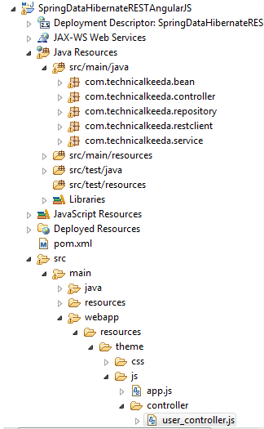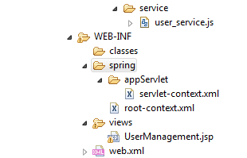
Pom.xml:
<?xml version="1.0" encoding="UTF-8"?>
<project xmlns="http://maven.apache.org/POM/4.0.0" xmlns:xsi="http://www.w3.org/2001/XMLSchema-instance"
xsi:schemaLocation="http://maven.apache.org/POM/4.0.0 http://maven.apache.org/maven-v4_0_0.xsd">
<modelVersion>4.0.0</modelVersion>
<groupId>com.tcs</groupId>
<artifactId>controller</artifactId>
<name>SpringDataHibernateRESTAngularJS</name>
<packaging>war</packaging>
<version>1.0.0-BUILD-SNAPSHOT</version>
<properties>
<java-version>1.8</java-version>
<org.springframework-version>4.0.0.RELEASE</org.springframework-version>
<org.aspectj-version>1.6.10</org.aspectj-version>
<org.slf4j-version>1.6.6</org.slf4j-version>
</properties>
<dependencies>
<dependency>
<groupId>org.springframework</groupId>
<artifactId>spring-context</artifactId>
<version>${org.springframework-version}</version>
<exclusions>
<!-- Exclude Commons Logging in favor of SLF4j -->
<exclusion>
<groupId>commons-logging</groupId>
<artifactId>commons-logging</artifactId>
</exclusion>
</exclusions>
</dependency>
<dependency>
<groupId>org.springframework</groupId>
<artifactId>spring-webmvc</artifactId>
<version>${org.springframework-version}</version>
</dependency>

<!-- AspectJ -->
<dependency>
<groupId>org.aspectj</groupId>
<artifactId>aspectjrt</artifactId>
<version>${org.aspectj-version}</version>
</dependency>

<!-- Logging -->
<dependency>
<groupId>org.slf4j</groupId>
<artifactId>slf4j-api</artifactId>
<version>${org.slf4j-version}</version>
</dependency>
<dependency>
<groupId>org.slf4j</groupId>
<artifactId>jcl-over-slf4j</artifactId>
<version>${org.slf4j-version}</version>
<scope>runtime</scope>
</dependency>
<dependency>
<groupId>org.slf4j</groupId>
<artifactId>slf4j-log4j12</artifactId>
<version>${org.slf4j-version}</version>
<scope>runtime</scope>
</dependency>
<dependency>
<groupId>log4j</groupId>
<artifactId>log4j</artifactId>
<version>1.2.15</version>
<exclusions>
<exclusion>
<groupId>javax.mail</groupId>
<artifactId>mail</artifactId>
</exclusion>
<exclusion>
<groupId>javax.jms</groupId>
<artifactId>jms</artifactId>
</exclusion>
<exclusion>
<groupId>com.sun.jdmk</groupId>
<artifactId>jmxtools</artifactId>
</exclusion>
<exclusion>
<groupId>com.sun.jmx</groupId>
<artifactId>jmxri</artifactId>
</exclusion>
</exclusions>
<scope>runtime</scope>
</dependency>

<!-- @Inject -->
<dependency>
<groupId>javax.inject</groupId>
<artifactId>javax.inject</artifactId>
<version>1</version>
</dependency>

<!-- Servlet -->

<dependency>
<groupId>javax.servlet.jsp</groupId>
<artifactId>jsp-api</artifactId>
<version>2.1</version>
<scope>provided</scope>
</dependency>
<dependency>
<groupId>javax.servlet</groupId>
<artifactId>jstl</artifactId>
<version>1.2</version>
</dependency>

<!-- Test -->
<dependency>
<groupId>junit</groupId>
<artifactId>junit</artifactId>
<version>4.7</version>
<scope>test</scope>
</dependency>

<!-- MySQL database driver -->
<dependency>
<groupId>mysql</groupId>
<artifactId>mysql-connector-java</artifactId>
<version>5.1.9</version>
</dependency>

<!-- Hibernate framework -->
<dependency>
<groupId>org.hibernate</groupId>
<artifactId>hibernate-core</artifactId>
<version>4.2.4.Final</version>
</dependency>

<dependency>
<groupId>org.springframework</groupId>
<artifactId>spring-orm</artifactId>
<version>${org.springframework-version}</version>
</dependency>
<dependency>
<groupId>org.aspectj</groupId>
<artifactId>aspectjrt</artifactId>
<version>${org.aspectj-version}</version>
</dependency>

<dependency>
<groupId>org.springframework</groupId>
<artifactId>spring-web</artifactId>
<version>${org.springframework-version}</version>
</dependency>
<dependency>
<groupId>org.springframework</groupId>
<artifactId>spring-jdbc</artifactId>
<version>${org.springframework-version}</version>
</dependency>

<dependency>
<groupId>com.fasterxml.jackson.core</groupId>
<artifactId>jackson-databind</artifactId>
<version>2.4.1</version>
</dependency>

<dependency>
<groupId>com.sun</groupId>
<artifactId>tools</artifactId>
<version>1.6</version>
<scope>system</scope>
<systemPath>C:\Program Files\Java\jdk1.8.0_131\lib\tools.jar</systemPath>
</dependency>

<!-- Spring Data JPA -->
<dependency>
<groupId>org.springframework.data</groupId>
<artifactId>spring-data-jpa</artifactId>
<version>1.0.2.RELEASE</version>
</dependency>

<dependency>
<groupId>org.hibernate</groupId>
<artifactId>hibernate-entitymanager</artifactId>
<version>4.2.4.Final</version>
</dependency>

</dependencies>
<build>
<finalName>SpringDataHibernateRESTAngularJS</finalName>
<plugins>
<plugin>
<artifactId>maven-eclipse-plugin</artifactId>
<version>2.9</version>
<configuration>
<additionalProjectnatures>
<projectnature>org.springframework.ide.eclipse.core.springnature</projectnature>
</additionalProjectnatures>
<additionalBuildcommands>
<buildcommand>org.springframework.ide.eclipse.core.springbuilder</buildcommand>
</additionalBuildcommands>
<downloadSources>true</downloadSources>
<downloadJavadocs>true</downloadJavadocs>
</configuration>
</plugin>
<plugin>
<groupId>org.apache.maven.plugins</groupId>
<artifactId>maven-compiler-plugin</artifactId>
<version>2.5.1</version>
<configuration>
<source>1.6</source>
<target>1.6</target>
<compilerArgument>-Xlint:all</compilerArgument>
<showWarnings>true</showWarnings>
<showDeprecation>true</showDeprecation>
</configuration>
</plugin>
<plugin>
<groupId>org.codehaus.mojo</groupId>
<artifactId>exec-maven-plugin</artifactId>
<version>1.2.1</version>
<configuration>
<mainClass>org.test.int1.Main</mainClass>
</configuration>
</plugin>
</plugins>
</build>
</project>

Web.xml:
<?xml version="1.0" encoding="UTF-8"?>
<web-app xmlns:xsi="http://www.w3.org/2001/XMLSchema-instance"
xmlns="http://java.sun.com/xml/ns/javaee"
xsi:schemaLocation="http://java.sun.com/xml/ns/javaee http://java.sun.com/xml/ns/javaee/web-app_2_5.xsd"
version="2.5">
<context-param>
<param-name>contextConfigLocation</param-name>
<param-value>/WEB-INF/spring/root-context.xml</param-value>
</context-param>
<listener>
<listener-class>org.springframework.web.context.ContextLoaderListener</listener-class>
</listener>
<servlet>
<servlet-name>appServlet</servlet-name>
<servlet-class>org.springframework.web.servlet.DispatcherServlet</servlet-class>
<init-param>
<param-name>contextConfigLocation</param-name>
<param-value>/WEB-INF/spring/appServlet/servlet-context.xml</param-value>
</init-param>
<load-on-startup>1</load-on-startup>
</servlet>
<servlet-mapping>
<servlet-name>appServlet</servlet-name>
<url-pattern>/</url-pattern>
</servlet-mapping>
</web-app>
app.properties:
app.jdbc.driverClassName=com.mysql.jdbc.Driver
app.jdbc.url=jdbc:mysql://localhost:3306/hibernate
app.jdbc.username=root
app.jdbc.password=

Servlet-context.xml:
<?xml version="1.0" encoding="UTF-8"?>
<beans:beans xmlns="http://www.springframework.org/schema/mvc"
xmlns:jpa="http://www.springframework.org/schema/data/jpa"
xmlns:xsi="http://www.w3.org/2001/XMLSchema-instance" xmlns:beans="http://www.springframework.org/schema/beans"
xmlns:p="http://www.springframework.org/schema/p"
xmlns:context="http://www.springframework.org/schema/context" xmlns:tx="http://www.springframework.org/schema/tx"
xsi:schemaLocation="http://www.springframework.org/schema/mvc http://www.springframework.org/schema/mvc/spring-mvc.xsd
http://www.springframework.org/schema/beans http://www.springframework.org/schema/beans/spring-beans.xsd
http://www.springframework.org/schema/tx http://www.springframework.org/schema/tx/spring-tx.xsd
http://www.springframework.org/schema/data/jpa http://www.springframework.org/schema/data/jpa/spring-jpa-1.0.xsd
http://www.springframework.org/schema/context http://www.springframework.org/schema/context/spring-context.xsd">

<annotation-driven />

<context:property-placeholder location="classpath:app.properties" />
<context:component-scan base-package="com.technicalkeeda" />

<resources mapping="/resources/**" location="/resources/theme/" />

<beans:bean class="org.springframework.web.servlet.view.InternalResourceViewResolver">
<beans:property name="prefix" value="/WEB-INF/views/" />
<beans:property name="suffix" value=".jsp" />
</beans:bean>

<beans:bean id="dataSource"
class="org.springframework.jdbc.datasource.DriverManagerDataSource">
<beans:property name="driverClassName" value="${app.jdbc.driverClassName}" />
<beans:property name="url" value="${app.jdbc.url}" />
<beans:property name="username" value="${app.jdbc.username}" />
<beans:property name="password" value="${app.jdbc.password}" />
</beans:bean>

<beans:bean id="transactionManager" class="org.springframework.orm.jpa.JpaTransactionManager">
<beans:property name="entityManagerFactory" ref="entityManagerFactory"/>
</beans:bean>

<tx:annotation-driven/>

<beans:bean id="hibernateJpaVendorAdapter" class="org.springframework.orm.jpa.vendor.HibernateJpaVendorAdapter"/>

<beans:bean id="entityManagerFactory" class="org.springframework.orm.jpa.LocalContainerEntityManagerFactoryBean">
<beans:property name="dataSource" ref="dataSource"/>
<beans:property name="jpaVendorAdapter" ref="hibernateJpaVendorAdapter"/>
<beans:property name="packagesToScan" value="com.technicalkeeda.bean"/>
<beans:property name="jpaProperties">
<beans:props>
<beans:prop key="hibernate.dialect">org.hibernate.dialect.MySQLDialect</beans:prop>
<beans:prop key="hibernate.hbm2ddl.auto">update</beans:prop>
<beans:prop key="hibernate.ejb.naming_strategy">org.hibernate.cfg.ImprovedNamingStrategy</beans:prop>
<beans:prop key="hibernate.show_sql">true</beans:prop>
<beans:prop key="hibernate.format_sql">true</beans:prop>
</beans:props>
</beans:property>
</beans:bean>

<jpa:repositories base-package="com.technicalkeeda.repository"/>
</beans:beans>

User.java:
package com.technicalkeeda.bean;

import javax.persistence.Column;
import javax.persistence.Entity;
import javax.persistence.GeneratedValue;
import javax.persistence.GenerationType;
import javax.persistence.Id;
import javax.persistence.Table;

import com.fasterxml.jackson.annotation.JsonIgnoreProperties;

@Entity
@Table(name = "users")
@JsonIgnoreProperties(ignoreUnknown = true)
public class User {
@Id
@GeneratedValue(strategy = GenerationType.IDENTITY)
private int id;
@Column
private String username;
@Column
private String address;
@Column
private String email;

public int getId() {
return id;
}

public void setId(int id) {
this.id = id;
}

public String getUsername() {
return username;
}

public void setUsername(String username) {
this.username = username;
}

public String getAddress() {
return address;
}

public void setAddress(String address) {
this.address = address;
}

public String getEmail() {
return email;
}

public void setEmail(String email) {
this.email = email;
}

@Override
public int hashCode() {
final int prime = 31;
int result = 1;
result = prime * result + (int) (id ^ (id >>> 32));
return result;
}

@Override
public boolean equals(Object obj) {
if (this == obj)
return true;
if (obj == null)
return false;
if (!(obj instanceof User))
return false;
User other = (User) obj;
if (id != other.id)
return false;
return true;
}

@Override
public String toString() {
return "User [id=" + id + ", username=" + username + ", address="
+ address + ", email=" + email + "]";
}

}

UserRepository.java:
package com.technicalkeeda.repository;

import org.springframework.data.jpa.repository.JpaRepository;
import com.technicalkeeda.bean.User;

public interface UserRepository extends JpaRepository<User, Integer>{
}
UserService.java:
package com.technicalkeeda.service;

import java.util.List;
import com.technicalkeeda.bean.User;

public interface UserService {

public User findById(int id);

public User saveUser(User user);

public User updateUser(User user);

public User deleteUserById(int id);

public List<User> findAllUsers();

}

UserServiceImpl.java:
package com.technicalkeeda.service;

import java.util.List;
import javax.annotation.Resource;
import javax.persistence.EntityManager;
import javax.persistence.PersistenceContext;
import org.springframework.stereotype.Service;
import org.springframework.transaction.annotation.Transactional;
import com.technicalkeeda.bean.User;
import com.technicalkeeda.repository.UserRepository;

@Service("userService")
public class UserServiceImpl implements UserService {

@Resource
private UserRepository userRepository;

@PersistenceContext
EntityManager entityManager;

@Override
public User findById(int id) {
return userRepository.findOne(id);
}

@Override
public User saveUser(User user) {
User createdUser = user;
return userRepository.save(createdUser);
}

@Override
@Transactional
public User updateUser(User user) {
User updatedUser = userRepository.findOne(user.getId());
updatedUser.setId(user.getId());
updatedUser.setUsername(user.getUsername());
updatedUser.setAddress(user.getAddress());
updatedUser.setEmail(user.getEmail());
System.out.println("Updated User Details:");
System.out.println(updatedUser.getId() + "\t"
+ updatedUser.getUsername() + "\t" + updatedUser.getAddress()
+ "\t" + updatedUser.getEmail());
return updatedUser;
}

@Override
public User deleteUserById(int id) {
User deletedUser = userRepository.findOne(id);
userRepository.delete(deletedUser);
return deletedUser;
}

@Override
public List<User> findAllUsers() {
return userRepository.findAll();
}

}
UserController.java:
package com.technicalkeeda.controller;

import java.util.List;
import java.util.Locale;
import org.springframework.beans.factory.annotation.Autowired;
import org.springframework.http.HttpHeaders;
import org.springframework.http.HttpStatus;
import org.springframework.http.MediaType;
import org.springframework.http.ResponseEntity;
import org.springframework.stereotype.Controller;
import org.springframework.ui.Model;
import org.springframework.web.bind.annotation.PathVariable;
import org.springframework.web.bind.annotation.RequestBody;
import org.springframework.web.bind.annotation.RequestMapping;
import org.springframework.web.bind.annotation.RequestMethod;
import org.springframework.web.util.UriComponentsBuilder;
import com.technicalkeeda.bean.User;
import com.technicalkeeda.service.UserService;

@Controller
public class UserController {

@Autowired
UserService userService; //Service which will do all data retrieval/manipulation work

@RequestMapping(value = "/UserManagement", method = RequestMethod.GET)
public String loginPage(Locale locale, Model model) {
return "UserManagement";
}

//-------------------Retrieve All Users------------------------------------------

@RequestMapping(value = "/user", method = RequestMethod.GET)
public ResponseEntity<List<User>> listAllUsers() {
List<User> users = userService.findAllUsers();
if(users.isEmpty()){
return new ResponseEntity<List<User>>(HttpStatus.NO_CONTENT);//You many decide to return HttpStatus.NOT_FOUND
}
return new ResponseEntity<List<User>>(users, HttpStatus.OK);
}

//-------------------Retrieve Single User----------------------------------------

@RequestMapping(value = "/user/{id}", method = RequestMethod.GET, produces = MediaType.APPLICATION_JSON_VALUE)
public ResponseEntity<User> getUser(@PathVariable("id") int id) {
System.out.println("Fetching User with id " + id);
User user = userService.findById(id);
if (user == null) {
System.out.println("User with id " + id + " not found");
return new ResponseEntity<User>(HttpStatus.NOT_FOUND);
}
return new ResponseEntity<User>(user, HttpStatus.OK);
}

//-------------------Create a User-----------------------------------------------

@RequestMapping(value = "/user", method = RequestMethod.POST)
public ResponseEntity<Void> createUser(@RequestBody User user, UriComponentsBuilder ucBuilder) {
System.out.println("Creating User " + user.getUsername());

userService.saveUser(user);

HttpHeaders headers = new HttpHeaders();
headers.setLocation(ucBuilder.path("/user/{id}").buildAndExpand(user.getId()).toUri());
return new ResponseEntity<Void>(headers, HttpStatus.CREATED);
}

//------------------- Update a User ---------------------------------------------

@RequestMapping(value = "/user/{id}", method = RequestMethod.PUT)
public ResponseEntity<User> updateUser(@PathVariable("id") int id, @RequestBody User user) {
System.out.println("Updating User " + id);

userService.updateUser(user);
return new ResponseEntity<User>(user, HttpStatus.OK);
}

//------------------- Delete a User ---------------------------------------------

@RequestMapping(value = "/user/{id}", method = RequestMethod.DELETE)
public ResponseEntity<User> deleteUser(@PathVariable("id") int id) {
System.out.println("Fetching & Deleting User with id " + id);

User user = userService.findById(id);
if (user == null) {
System.out.println("Unable to delete. User with id " + id + " not found");
return new ResponseEntity<User>(HttpStatus.NOT_FOUND);
}

userService.deleteUserById(id);
return new ResponseEntity<User>(HttpStatus.NO_CONTENT);
}

}
UserManagement.jsp:
<%@ page language="java" contentType="text/html; charset=ISO-8859-1" pageEncoding="ISO-8859-1"%>
<%@ taglib prefix="c" uri="http://java.sun.com/jsp/jstl/core" %>
<html>
<head>
<title>AngularJS ngResource Example</title>
<style>
.username.ng-valid {
background-color: lightgreen;
}
.username.ng-dirty.ng-invalid-required {
background-color: red;
}
.username.ng-dirty.ng-invalid-minlength {
background-color: yellow;
}

.email.ng-valid {
background-color: lightgreen;
}
.email.ng-dirty.ng-invalid-required {
background-color: red;
}
.email.ng-dirty.ng-invalid-email {
background-color: yellow;
}

</style>
<link rel="stylesheet" href="https://maxcdn.bootstrapcdn.com/bootstrap/3.3.5/css/bootstrap.min.css">
<link href="<c:url value='/resources/css/app.css' />" rel="stylesheet"></link>
</head>
<body ng-app="myApp" class="ng-cloak">
<div class="generic-container" ng-controller="UserController as ctrl">
<div class="panel panel-default">
<div class="panel-heading"><span class="lead">User Registration Form </span></div>
<div class="formcontainer">
<form ng-submit="ctrl.submit()" name="myForm" class="form-horizontal">
<input type="hidden" ng-model="ctrl.user.id" />
<div class="row">
<div class="form-group col-md-12">
<label class="col-md-2 control-lable" for="uname">Name</label>
<div class="col-md-7">
<input type="text" ng-model="ctrl.user.username" id="uname" class="username form-control input-sm" placeholder="Enter your name" required ng-minlength="3"/>
<div class="has-error" ng-show="myForm.$dirty">
<span ng-show="myForm.uname.$error.required">This is a required field</span>
<span ng-show="myForm.uname.$error.minlength">Minimum length required is 3</span>
<span ng-show="myForm.uname.$invalid">This field is invalid </span>
</div>
</div>
</div>
</div>

<div class="row">
<div class="form-group col-md-12">
<label class="col-md-2 control-lable" for="address">Address</label>
<div class="col-md-7">
<input type="text" ng-model="ctrl.user.address" id="address" class="form-control input-sm" placeholder="Enter your Address. [This field is validation free]"/>
</div>
</div>
</div>

<div class="row">
<div class="form-group col-md-12">
<label class="col-md-2 control-lable" for="email">Email</label>
<div class="col-md-7">
<input type="email" ng-model="ctrl.user.email" id="email" class="email form-control input-sm" placeholder="Enter your Email" required/>
<div class="has-error" ng-show="myForm.$dirty">
<span ng-show="myForm.email.$error.required">This is a required field</span>
<span ng-show="myForm.email.$invalid">This field is invalid </span>
</div>
</div>
</div>
</div>

<div class="row">
<div class="form-actions floatRight">
<input type="submit" value="{{!ctrl.user.id ? 'Add' : 'Update'}}" class="btn btn-primary btn-sm" ng-disabled="myForm.$invalid">
<button type="button" ng-click="ctrl.reset()" class="btn btn-warning btn-sm" ng-disabled="myForm.$pristine">Reset Form</button>
</div>
</div>
</form>
</div>
</div>
<div class="panel panel-default">
<!-- Default panel contents -->
<div class="panel-heading"><span class="lead">List of Users </span></div>
<div class="tablecontainer">
<table class="table table-hover">
<thead>
<tr>
<th>ID.</th>
<th>Name</th>
<th>Address</th>
<th>Email</th>
<th width="20%"></th>
</tr>
</thead>
<tbody>
<tr ng-repeat="u in ctrl.users">
<td><span ng-bind="u.id"></span></td>
<td><span ng-bind="u.username"></span></td>
<td><span ng-bind="u.address"></span></td>
<td><span ng-bind="u.email"></span></td>
<td>
<button type="button" ng-click="ctrl.edit(u.id)" class="btn btn-success custom-width">Edit</button> <button type="button" ng-click="ctrl.remove(u.id)" class="btn btn-danger custom-width">Remove</button>
</td>
</tr>
</tbody>
</table>
</div>
</div>
</div>

<script src="https://ajax.googleapis.com/ajax/libs/angularjs/1.4.4/angular.js"></script>
<script src="https://ajax.googleapis.com/ajax/libs/angularjs/1.4.4/angular-resource.js"></script>
<script src="<c:url value='/resources/js/app.js' />"></script>
<script src="<c:url value='/resources/js/service/user_service.js' />"></script>
<script src="<c:url value='/resources/js/controller/user_controller.js' />"></script>
</body>
</html>
app.css:
body, #mainWrapper {
height: 70%;
background-color:rgb(245, 245, 245);
}

body, .form-control{
font-size:12px!important;
}

.floatRight{
float:right;
margin-right: 18px;
}

.has-error{
color:red;
}

.formcontainer{
background-color: #DAE8E8;
padding: 20px;
}

.tablecontainer{
padding-left: 20px;
}

.generic-container {
width:80%;
margin-left: 20px;
margin-top: 20px;
margin-bottom: 20px;
padding: 20px;
background-color: #EAE7E7;
border: 1px solid #ddd;
border-radius: 4px;
box-shadow: 0 0 30px black;
}

.custom-width {
width: 80px !important;
}

app.js:
'use strict';

var App = angular.module('myApp',['ngResource']);

user_controller.js:
'use strict';

App.controller('UserController', ['$scope', 'User', function($scope, User) {
var self = this;
self.user= new User();

self.users=[];

self.fetchAllUsers = function(){
self.users = User.query();
};

self.createUser = function(){
self.user.$save(function(){
self.fetchAllUsers();
});
};

self.updateUser = function(){
self.user.$update(function(){
self.fetchAllUsers();
});
};

self.deleteUser = function(identity){
var user = User.get({id:identity}, function() {
user.$delete(function(){
console.log('Deleting user with id ', identity);
self.fetchAllUsers();
});
});
};

self.fetchAllUsers();

self.submit = function() {
if(self.user.id==null){
console.log('Saving New User', self.user);
self.createUser();
}else{
console.log('Upddating user with id ', self.user.id);
self.updateUser();
console.log('User updated with id ', self.user.id);
}
self.reset();
};

self.edit = function(id){
console.log('id to be edited', id);
for(var i = 0; i < self.users.length; i++){
if(self.users[i].id === id) {
self.user = angular.copy(self.users[i]);
break;
}
}
};

self.remove = function(id){
console.log('id to be deleted', id);
if(self.user.id === id) {//If it is the one shown on screen, reset screen
self.reset();
}
self.deleteUser(id);
};

self.reset = function(){
self.user= new User();
$scope.myForm.$setPristine(); //reset Form
};

}]);

user_service.js:
'use strict';
App.factory('User', ['$resource', function ($resource) {
//$resource() function returns an object of resource class
return $resource(
'http://localhost:8085/SpringDataHibernateRESTAngularJS/user/:id',
{id: '@id'},//Handy for update & delete. id will be set with id of instance
{
update: {
method: 'PUT' // To send the HTTP Put request when calling this custom update method.
}
}
);
}]);

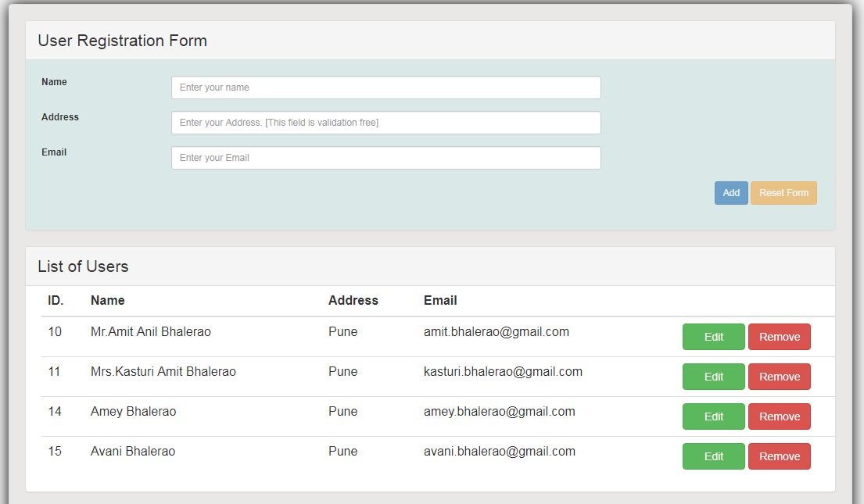

- Using $http Service :
Project Structure:

Pom.xml:
<?xml version="1.0" encoding="UTF-8"?>
<project xmlns="http://maven.apache.org/POM/4.0.0" xmlns:xsi="http://www.w3.org/2001/XMLSchema-instance"
xsi:schemaLocation="http://maven.apache.org/POM/4.0.0 http://maven.apache.org/maven-v4_0_0.xsd">
<modelVersion>4.0.0</modelVersion>
<groupId>com.tcs</groupId>
<artifactId>controller</artifactId>
<name>SpringDataHibernateRESTAngularJS</name>
<packaging>war</packaging>
<version>1.0.0-BUILD-SNAPSHOT</version>
<properties>
<java-version>1.8</java-version>
<org.springframework-version>4.0.0.RELEASE</org.springframework-version>
<org.aspectj-version>1.6.10</org.aspectj-version>
<org.slf4j-version>1.6.6</org.slf4j-version>
</properties>
<dependencies>
<dependency>
<groupId>org.springframework</groupId>
<artifactId>spring-context</artifactId>
<version>${org.springframework-version}</version>
<exclusions>
<!-- Exclude Commons Logging in favor of SLF4j -->
<exclusion>
<groupId>commons-logging</groupId>
<artifactId>commons-logging</artifactId>
</exclusion>
</exclusions>
</dependency>
<dependency>
<groupId>org.springframework</groupId>
<artifactId>spring-webmvc</artifactId>
<version>${org.springframework-version}</version>
</dependency>

<!-- AspectJ -->
<dependency>
<groupId>org.aspectj</groupId>
<artifactId>aspectjrt</artifactId>
<version>${org.aspectj-version}</version>
</dependency>

<!-- Logging -->
<dependency>
<groupId>org.slf4j</groupId>
<artifactId>slf4j-api</artifactId>
<version>${org.slf4j-version}</version>
</dependency>
<dependency>
<groupId>org.slf4j</groupId>
<artifactId>jcl-over-slf4j</artifactId>
<version>${org.slf4j-version}</version>
<scope>runtime</scope>
</dependency>
<dependency>
<groupId>org.slf4j</groupId>
<artifactId>slf4j-log4j12</artifactId>
<version>${org.slf4j-version}</version>
<scope>runtime</scope>
</dependency>
<dependency>
<groupId>log4j</groupId>
<artifactId>log4j</artifactId>
<version>1.2.15</version>
<exclusions>
<exclusion>
<groupId>javax.mail</groupId>
<artifactId>mail</artifactId>
</exclusion>
<exclusion>
<groupId>javax.jms</groupId>
<artifactId>jms</artifactId>
</exclusion>
<exclusion>
<groupId>com.sun.jdmk</groupId>
<artifactId>jmxtools</artifactId>
</exclusion>
<exclusion>
<groupId>com.sun.jmx</groupId>
<artifactId>jmxri</artifactId>
</exclusion>
</exclusions>
<scope>runtime</scope>
</dependency>

<!-- @Inject -->
<dependency>
<groupId>javax.inject</groupId>
<artifactId>javax.inject</artifactId>
<version>1</version>
</dependency>

<!-- Servlet -->

<dependency>
<groupId>javax.servlet.jsp</groupId>
<artifactId>jsp-api</artifactId>
<version>2.1</version>
<scope>provided</scope>
</dependency>
<dependency>
<groupId>javax.servlet</groupId>
<artifactId>jstl</artifactId>
<version>1.2</version>
</dependency>

<!-- Test -->
<dependency>
<groupId>junit</groupId>
<artifactId>junit</artifactId>
<version>4.7</version>
<scope>test</scope>
</dependency>

<!-- MySQL database driver -->
<dependency>
<groupId>mysql</groupId>
<artifactId>mysql-connector-java</artifactId>
<version>5.1.9</version>
</dependency>

<!-- Hibernate framework -->
<dependency>
<groupId>org.hibernate</groupId>
<artifactId>hibernate-core</artifactId>
<version>4.2.4.Final</version>
</dependency>

<dependency>
<groupId>org.springframework</groupId>
<artifactId>spring-orm</artifactId>
<version>${org.springframework-version}</version>
</dependency>
<dependency>
<groupId>org.aspectj</groupId>
<artifactId>aspectjrt</artifactId>
<version>${org.aspectj-version}</version>
</dependency>

<dependency>
<groupId>org.springframework</groupId>
<artifactId>spring-web</artifactId>
<version>${org.springframework-version}</version>
</dependency>
<dependency>
<groupId>org.springframework</groupId>
<artifactId>spring-jdbc</artifactId>
<version>${org.springframework-version}</version>
</dependency>

<dependency>
<groupId>com.fasterxml.jackson.core</groupId>
<artifactId>jackson-databind</artifactId>
<version>2.4.1</version>
</dependency>

<dependency>
<groupId>com.sun</groupId>
<artifactId>tools</artifactId>
<version>1.6</version>
<scope>system</scope>
<systemPath>C:\Program Files\Java\jdk1.8.0_131\lib\tools.jar</systemPath>
</dependency>

<!-- Spring Data JPA -->
<dependency>
<groupId>org.springframework.data</groupId>
<artifactId>spring-data-jpa</artifactId>
<version>1.0.2.RELEASE</version>
</dependency>

<dependency>
<groupId>org.hibernate</groupId>
<artifactId>hibernate-entitymanager</artifactId>
<version>4.2.4.Final</version>
</dependency>

</dependencies>
<build>
<finalName>SpringDataHibernateRESTAngularJS</finalName>
<plugins>
<plugin>
<artifactId>maven-eclipse-plugin</artifactId>
<version>2.9</version>
<configuration>
<additionalProjectnatures>
<projectnature>org.springframework.ide.eclipse.core.springnature</projectnature>
</additionalProjectnatures>
<additionalBuildcommands>
<buildcommand>org.springframework.ide.eclipse.core.springbuilder</buildcommand>
</additionalBuildcommands>
<downloadSources>true</downloadSources>
<downloadJavadocs>true</downloadJavadocs>
</configuration>
</plugin>
<plugin>
<groupId>org.apache.maven.plugins</groupId>
<artifactId>maven-compiler-plugin</artifactId>
<version>2.5.1</version>
<configuration>
<source>1.6</source>
<target>1.6</target>
<compilerArgument>-Xlint:all</compilerArgument>
<showWarnings>true</showWarnings>
<showDeprecation>true</showDeprecation>
</configuration>
</plugin>
<plugin>
<groupId>org.codehaus.mojo</groupId>
<artifactId>exec-maven-plugin</artifactId>
<version>1.2.1</version>
<configuration>
<mainClass>org.test.int1.Main</mainClass>
</configuration>
</plugin>
</plugins>
</build>
</project>

Web.xml:
<?xml version="1.0" encoding="UTF-8"?>
<web-app xmlns:xsi="http://www.w3.org/2001/XMLSchema-instance"
xmlns="http://java.sun.com/xml/ns/javaee"
xsi:schemaLocation="http://java.sun.com/xml/ns/javaee http://java.sun.com/xml/ns/javaee/web-app_2_5.xsd"
version="2.5">
<context-param>
<param-name>contextConfigLocation</param-name>
<param-value>/WEB-INF/spring/root-context.xml</param-value>
</context-param>
<listener>
<listener-class>org.springframework.web.context.ContextLoaderListener</listener-class>
</listener>
<servlet>
<servlet-name>appServlet</servlet-name>
<servlet-class>org.springframework.web.servlet.DispatcherServlet</servlet-class>
<init-param>
<param-name>contextConfigLocation</param-name>
<param-value>/WEB-INF/spring/appServlet/servlet-context.xml</param-value>
</init-param>
<load-on-startup>1</load-on-startup>
</servlet>
<servlet-mapping>
<servlet-name>appServlet</servlet-name>
<url-pattern>/</url-pattern>
</servlet-mapping>
</web-app>
app.properties:
app.jdbc.driverClassName=com.mysql.jdbc.Driver
app.jdbc.url=jdbc:mysql://localhost:3306/hibernate
app.jdbc.username=root
app.jdbc.password=

Servlet-context.xml:
<?xml version="1.0" encoding="UTF-8"?>
<beans:beans xmlns="http://www.springframework.org/schema/mvc"
xmlns:jpa="http://www.springframework.org/schema/data/jpa"
xmlns:xsi="http://www.w3.org/2001/XMLSchema-instance" xmlns:beans="http://www.springframework.org/schema/beans"
xmlns:p="http://www.springframework.org/schema/p"
xmlns:context="http://www.springframework.org/schema/context" xmlns:tx="http://www.springframework.org/schema/tx"
xsi:schemaLocation="http://www.springframework.org/schema/mvc http://www.springframework.org/schema/mvc/spring-mvc.xsd
http://www.springframework.org/schema/beans http://www.springframework.org/schema/beans/spring-beans.xsd
http://www.springframework.org/schema/tx http://www.springframework.org/schema/tx/spring-tx.xsd
http://www.springframework.org/schema/data/jpa http://www.springframework.org/schema/data/jpa/spring-jpa-1.0.xsd
http://www.springframework.org/schema/context http://www.springframework.org/schema/context/spring-context.xsd">

<annotation-driven />

<context:property-placeholder location="classpath:app.properties" />
<context:component-scan base-package="com.technicalkeeda" />

<resources mapping="/resources/**" location="/resources/theme/" />

<beans:bean class="org.springframework.web.servlet.view.InternalResourceViewResolver">
<beans:property name="prefix" value="/WEB-INF/views/" />
<beans:property name="suffix" value=".jsp" />
</beans:bean>

<beans:bean id="dataSource"
class="org.springframework.jdbc.datasource.DriverManagerDataSource">
<beans:property name="driverClassName" value="${app.jdbc.driverClassName}" />
<beans:property name="url" value="${app.jdbc.url}" />
<beans:property name="username" value="${app.jdbc.username}" />
<beans:property name="password" value="${app.jdbc.password}" />
</beans:bean>

<beans:bean id="transactionManager" class="org.springframework.orm.jpa.JpaTransactionManager">
<beans:property name="entityManagerFactory" ref="entityManagerFactory"/>
</beans:bean>

<tx:annotation-driven/>

<beans:bean id="hibernateJpaVendorAdapter" class="org.springframework.orm.jpa.vendor.HibernateJpaVendorAdapter"/>

<beans:bean id="entityManagerFactory" class="org.springframework.orm.jpa.LocalContainerEntityManagerFactoryBean">
<beans:property name="dataSource" ref="dataSource"/>
<beans:property name="jpaVendorAdapter" ref="hibernateJpaVendorAdapter"/>
<beans:property name="packagesToScan" value="com.technicalkeeda.bean"/>
<beans:property name="jpaProperties">
<beans:props>
<beans:prop key="hibernate.dialect">org.hibernate.dialect.MySQLDialect</beans:prop>
<beans:prop key="hibernate.hbm2ddl.auto">update</beans:prop>
<beans:prop key="hibernate.ejb.naming_strategy">org.hibernate.cfg.ImprovedNamingStrategy</beans:prop>
<beans:prop key="hibernate.show_sql">true</beans:prop>
<beans:prop key="hibernate.format_sql">true</beans:prop>
</beans:props>
</beans:property>
</beans:bean>

<jpa:repositories base-package="com.technicalkeeda.repository"/>
</beans:beans>

User.java:
package com.technicalkeeda.bean;

import javax.persistence.Column;
import javax.persistence.Entity;
import javax.persistence.GeneratedValue;
import javax.persistence.GenerationType;
import javax.persistence.Id;
import javax.persistence.Table;

import com.fasterxml.jackson.annotation.JsonIgnoreProperties;

@Entity
@Table(name = "users")
@JsonIgnoreProperties(ignoreUnknown = true)
public class User {
@Id
@GeneratedValue(strategy = GenerationType.IDENTITY)
private int id;
@Column
private String username;
@Column
private String address;
@Column
private String email;

public int getId() {
return id;
}

public void setId(int id) {
this.id = id;
}

public String getUsername() {
return username;
}

public void setUsername(String username) {
this.username = username;
}

public String getAddress() {
return address;
}

public void setAddress(String address) {
this.address = address;
}

public String getEmail() {
return email;
}

public void setEmail(String email) {
this.email = email;
}

@Override
public int hashCode() {
final int prime = 31;
int result = 1;
result = prime * result + (int) (id ^ (id >>> 32));
return result;
}

@Override
public boolean equals(Object obj) {
if (this == obj)
return true;
if (obj == null)
return false;
if (!(obj instanceof User))
return false;
User other = (User) obj;
if (id != other.id)
return false;
return true;
}

@Override
public String toString() {
return "User [id=" + id + ", username=" + username + ", address="
+ address + ", email=" + email + "]";
}

}

UserRepository.java:
package com.technicalkeeda.repository;

import org.springframework.data.jpa.repository.JpaRepository;
import com.technicalkeeda.bean.User;

public interface UserRepository extends JpaRepository<User, Integer>{
}
UserService.java:
package com.technicalkeeda.service;

import java.util.List;
import com.technicalkeeda.bean.User;

public interface UserService {

public User findById(int id);

public User saveUser(User user);

public User updateUser(User user);

public User deleteUserById(int id);

public List<User> findAllUsers();

}

UserServiceImpl.java:
package com.technicalkeeda.service;

import java.util.List;
import javax.annotation.Resource;
import javax.persistence.EntityManager;
import javax.persistence.PersistenceContext;
import org.springframework.stereotype.Service;
import org.springframework.transaction.annotation.Transactional;
import com.technicalkeeda.bean.User;
import com.technicalkeeda.repository.UserRepository;

@Service("userService")
public class UserServiceImpl implements UserService {

@Resource
private UserRepository userRepository;

@PersistenceContext
EntityManager entityManager;

@Override
public User findById(int id) {
return userRepository.findOne(id);
}

@Override
public User saveUser(User user) {
User createdUser = user;
return userRepository.save(createdUser);
}

@Override
@Transactional
public User updateUser(User user) {
User updatedUser = userRepository.findOne(user.getId());
updatedUser.setId(user.getId());
updatedUser.setUsername(user.getUsername());
updatedUser.setAddress(user.getAddress());
updatedUser.setEmail(user.getEmail());
System.out.println("Updated User Details:");
System.out.println(updatedUser.getId() + "\t"
+ updatedUser.getUsername() + "\t" + updatedUser.getAddress()
+ "\t" + updatedUser.getEmail());
return updatedUser;
}

@Override
public User deleteUserById(int id) {
User deletedUser = userRepository.findOne(id);
userRepository.delete(deletedUser);
return deletedUser;
}

@Override
public List<User> findAllUsers() {
return userRepository.findAll();
}

}
UserController.java:
package com.technicalkeeda.controller;

import java.util.List;
import java.util.Locale;
import org.springframework.beans.factory.annotation.Autowired;
import org.springframework.http.HttpHeaders;
import org.springframework.http.HttpStatus;
import org.springframework.http.MediaType;
import org.springframework.http.ResponseEntity;
import org.springframework.stereotype.Controller;
import org.springframework.ui.Model;
import org.springframework.web.bind.annotation.PathVariable;
import org.springframework.web.bind.annotation.RequestBody;
import org.springframework.web.bind.annotation.RequestMapping;
import org.springframework.web.bind.annotation.RequestMethod;
import org.springframework.web.util.UriComponentsBuilder;
import com.technicalkeeda.bean.User;
import com.technicalkeeda.service.UserService;

@Controller
public class UserController {

@Autowired
UserService userService; //Service which will do all data retrieval/manipulation work

@RequestMapping(value = "/UserManagement", method = RequestMethod.GET)
public String loginPage(Locale locale, Model model) {
return "UserManagement";
}

//-------------------Retrieve All Users------------------------------------------

@RequestMapping(value = "/user", method = RequestMethod.GET)
public ResponseEntity<List<User>> listAllUsers() {
List<User> users = userService.findAllUsers();
if(users.isEmpty()){
return new ResponseEntity<List<User>>(HttpStatus.NO_CONTENT);//You many decide to return HttpStatus.NOT_FOUND
}
return new ResponseEntity<List<User>>(users, HttpStatus.OK);
}

//-------------------Retrieve Single User----------------------------------------

@RequestMapping(value = "/user/{id}", method = RequestMethod.GET, produces = MediaType.APPLICATION_JSON_VALUE)
public ResponseEntity<User> getUser(@PathVariable("id") int id) {
System.out.println("Fetching User with id " + id);
User user = userService.findById(id);
if (user == null) {
System.out.println("User with id " + id + " not found");
return new ResponseEntity<User>(HttpStatus.NOT_FOUND);
}
return new ResponseEntity<User>(user, HttpStatus.OK);
}

//-------------------Create a User-----------------------------------------------

@RequestMapping(value = "/user", method = RequestMethod.POST)
public ResponseEntity<Void> createUser(@RequestBody User user, UriComponentsBuilder ucBuilder) {
System.out.println("Creating User " + user.getUsername());

userService.saveUser(user);

HttpHeaders headers = new HttpHeaders();
headers.setLocation(ucBuilder.path("/user/{id}").buildAndExpand(user.getId()).toUri());
return new ResponseEntity<Void>(headers, HttpStatus.CREATED);
}

//------------------- Update a User ---------------------------------------------

@RequestMapping(value = "/user/{id}", method = RequestMethod.PUT)
public ResponseEntity<User> updateUser(@PathVariable("id") int id, @RequestBody User user) {
System.out.println("Updating User " + id);

userService.updateUser(user);
return new ResponseEntity<User>(user, HttpStatus.OK);
}

//------------------- Delete a User ---------------------------------------------

@RequestMapping(value = "/user/{id}", method = RequestMethod.DELETE)
public ResponseEntity<User> deleteUser(@PathVariable("id") int id) {
System.out.println("Fetching & Deleting User with id " + id);

User user = userService.findById(id);
if (user == null) {
System.out.println("Unable to delete. User with id " + id + " not found");
return new ResponseEntity<User>(HttpStatus.NOT_FOUND);
}

userService.deleteUserById(id);
return new ResponseEntity<User>(HttpStatus.NO_CONTENT);
}

}
UserManagement.jsp:
<%@ page language="java" contentType="text/html; charset=ISO-8859-1" pageEncoding="ISO-8859-1"%>
<%@ taglib prefix="c" uri="http://java.sun.com/jsp/jstl/core" %>
<html>
<head>
<title>AngularJS ngResource Example</title>
<style>
.username.ng-valid {
background-color: lightgreen;
}
.username.ng-dirty.ng-invalid-required {
background-color: red;
}
.username.ng-dirty.ng-invalid-minlength {
background-color: yellow;
}

.email.ng-valid {
background-color: lightgreen;
}
.email.ng-dirty.ng-invalid-required {
background-color: red;
}
.email.ng-dirty.ng-invalid-email {
background-color: yellow;
}

</style>
<link rel="stylesheet" href="https://maxcdn.bootstrapcdn.com/bootstrap/3.3.5/css/bootstrap.min.css">
<link href="<c:url value='/resources/css/app.css' />" rel="stylesheet"></link>
</head>
<body ng-app="myApp" class="ng-cloak">
<div class="generic-container" ng-controller="UserController as ctrl">
<div class="panel panel-default">
<div class="panel-heading"><span class="lead">User Registration Form </span></div>
<div class="formcontainer">
<form ng-submit="ctrl.submit()" name="myForm" class="form-horizontal">
<input type="hidden" ng-model="ctrl.user.id" />
<div class="row">
<div class="form-group col-md-12">
<label class="col-md-2 control-lable" for="uname">Name</label>
<div class="col-md-7">
<input type="text" ng-model="ctrl.user.username" id="uname" class="username form-control input-sm" placeholder="Enter your name" required ng-minlength="3"/>
<div class="has-error" ng-show="myForm.$dirty">
<span ng-show="myForm.uname.$error.required">This is a required field</span>
<span ng-show="myForm.uname.$error.minlength">Minimum length required is 3</span>
<span ng-show="myForm.uname.$invalid">This field is invalid </span>
</div>
</div>
</div>
</div>

<div class="row">
<div class="form-group col-md-12">
<label class="col-md-2 control-lable" for="address">Address</label>
<div class="col-md-7">
<input type="text" ng-model="ctrl.user.address" id="address" class="form-control input-sm" placeholder="Enter your Address. [This field is validation free]"/>
</div>
</div>
</div>

<div class="row">
<div class="form-group col-md-12">
<label class="col-md-2 control-lable" for="email">Email</label>
<div class="col-md-7">
<input type="email" ng-model="ctrl.user.email" id="email" class="email form-control input-sm" placeholder="Enter your Email" required/>
<div class="has-error" ng-show="myForm.$dirty">
<span ng-show="myForm.email.$error.required">This is a required field</span>
<span ng-show="myForm.email.$invalid">This field is invalid </span>
</div>
</div>
</div>
</div>

<div class="row">
<div class="form-actions floatRight">
<input type="submit" value="{{!ctrl.user.id ? 'Add' : 'Update'}}" class="btn btn-primary btn-sm" ng-disabled="myForm.$invalid">
<button type="button" ng-click="ctrl.reset()" class="btn btn-warning btn-sm" ng-disabled="myForm.$pristine">Reset Form</button>
</div>
</div>
</form>
</div>
</div>
<div class="panel panel-default">
<!-- Default panel contents -->
<div class="panel-heading"><span class="lead">List of Users </span></div>
<div class="tablecontainer">
<table class="table table-hover">
<thead>
<tr>
<th>ID.</th>
<th>Name</th>
<th>Address</th>
<th>Email</th>
<th width="20%"></th>
</tr>
</thead>
<tbody>
<tr ng-repeat="u in ctrl.users">
<td><span ng-bind="u.id"></span></td>
<td><span ng-bind="u.username"></span></td>
<td><span ng-bind="u.address"></span></td>
<td><span ng-bind="u.email"></span></td>
<td>
<button type="button" ng-click="ctrl.edit(u.id)" class="btn btn-success custom-width">Edit</button> <button type="button" ng-click="ctrl.remove(u.id)" class="btn btn-danger custom-width">Remove</button>
</td>
</tr>
</tbody>
</table>
</div>
</div>
</div>

<script src="https://ajax.googleapis.com/ajax/libs/angularjs/1.4.4/angular.js"></script>
<script src="https://ajax.googleapis.com/ajax/libs/angularjs/1.4.4/angular-resource.js"></script>
<script src="<c:url value='/resources/js/app.js' />"></script>
<script src="<c:url value='/resources/js/service/user_service.js' />"></script>
<script src="<c:url value='/resources/js/controller/user_controller.js' />"></script>
</body>
</html>
app.css:
body, #mainWrapper {
height: 70%;
background-color:rgb(245, 245, 245);
}

body, .form-control{
font-size:12px!important;
}

.floatRight{
float:right;
margin-right: 18px;
}

.has-error{
color:red;
}

.formcontainer{
background-color: #DAE8E8;
padding: 20px;
}

.tablecontainer{
padding-left: 20px;
}

.generic-container {
width:80%;
margin-left: 20px;
margin-top: 20px;
margin-bottom: 20px;
padding: 20px;
background-color: #EAE7E7;
border: 1px solid #ddd;
border-radius: 4px;
box-shadow: 0 0 30px black;
}

.custom-width {
width: 80px !important;
}

app.js:
'use strict';

var App = angular.module('myApp',[]);

user_controller.js:
'use strict';

angular.module('myApp').controller('UserController', ['$scope', 'UserService', function($scope, UserService) {
var self = this;
self.user={id:null,username:'',address:'',email:''};
self.users=[];

self.submit = submit;
self.edit = edit;
self.remove = remove;
self.reset = reset;

fetchAllUsers();

function fetchAllUsers(){
UserService.fetchAllUsers()
.then(
function(d) {
self.users = d;
},
function(errResponse){
console.error('Error while fetching Users');
}
);
}

function createUser(user){
UserService.createUser(user)
.then(
fetchAllUsers,
function(errResponse){
console.error('Error while creating User');
}
);
}

function updateUser(user, id){
UserService.updateUser(user, id)
.then(
fetchAllUsers,
function(errResponse){
console.error('Error while updating User');
}
);
}

function deleteUser(id){
UserService.deleteUser(id)
.then(
fetchAllUsers,
function(errResponse){
console.error('Error while deleting User');
}
);
}

function submit() {
if(self.user.id===null){
console.log('Saving New User', self.user);
createUser(self.user);
}else{
updateUser(self.user, self.user.id);
console.log('User updated with id ', self.user.id);
}
reset();
}

function edit(id){
console.log('id to be edited', id);
for(var i = 0; i < self.users.length; i++){
if(self.users[i].id === id) {
self.user = angular.copy(self.users[i]);
break;
}
}
}

function remove(id){
console.log('id to be deleted', id);
if(self.user.id === id) {//clean form if the user to be deleted is shown there.
reset();
}
deleteUser(id);
}

function reset(){
self.user={id:null,username:'',address:'',email:''};
$scope.myForm.$setPristine(); //reset Form
}

}]);
user_service.js:
'use strict';

angular.module('myApp').factory('UserService', ['$http', '$q', function($http, $q){

var REST_SERVICE_URI = 'http://localhost:8085/SpringDataHibernateRESTAngularJS/user/';

var factory = {
fetchAllUsers: fetchAllUsers,
createUser: createUser,
updateUser:updateUser,
deleteUser:deleteUser
};

return factory;

function fetchAllUsers() {
var deferred = $q.defer();
$http.get(REST_SERVICE_URI)
.then(
function (response) {
deferred.resolve(response.data);
},
function(errResponse){
console.error('Error while fetching Users');
deferred.reject(errResponse);
}
);
return deferred.promise;
}

function createUser(user) {
var deferred = $q.defer();
$http.post(REST_SERVICE_URI, user)
.then(
function (response) {
deferred.resolve(response.data);
},
function(errResponse){
console.error('Error while creating User');
deferred.reject(errResponse);
}
);
return deferred.promise;
}

function updateUser(user, id) {
var deferred = $q.defer();
$http.put(REST_SERVICE_URI+id, user)
.then(
function (response) {
deferred.resolve(response.data);
},
function(errResponse){
console.error('Error while updating User');
deferred.reject(errResponse);
}
);
return deferred.promise;
}

function deleteUser(id) {
var deferred = $q.defer();
$http.delete(REST_SERVICE_URI+id)
.then(
function (response) {
deferred.resolve(response.data);
},
function(errResponse){
console.error('Error while deleting User');
deferred.reject(errResponse);
}
);
return deferred.promise;
}

}]);

Project Structure:
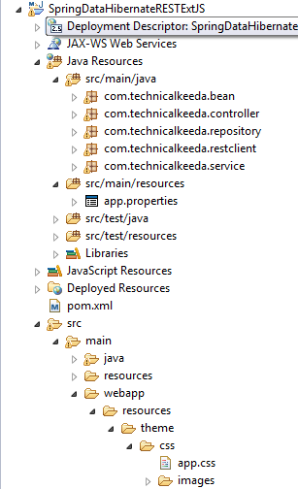
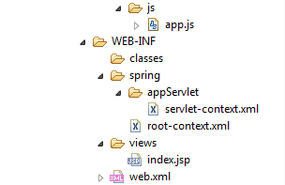

Pom.xml:
<?xml version="1.0" encoding="UTF-8"?>
<project xmlns="http://maven.apache.org/POM/4.0.0" xmlns:xsi="http://www.w3.org/2001/XMLSchema-instance"
xsi:schemaLocation="http://maven.apache.org/POM/4.0.0 http://maven.apache.org/maven-v4_0_0.xsd">
<modelVersion>4.0.0</modelVersion>
<groupId>com.tcs</groupId>
<artifactId>controller</artifactId>
<name>SpringDataHibernateRESTAngularJS</name>
<packaging>war</packaging>
<version>1.0.0-BUILD-SNAPSHOT</version>
<properties>
<java-version>1.8</java-version>
<org.springframework-version>4.0.0.RELEASE</org.springframework-version>
<org.aspectj-version>1.6.10</org.aspectj-version>
<org.slf4j-version>1.6.6</org.slf4j-version>
</properties>
<dependencies>
<dependency>
<groupId>org.springframework</groupId>
<artifactId>spring-context</artifactId>
<version>${org.springframework-version}</version>
<exclusions>
<!-- Exclude Commons Logging in favor of SLF4j -->
<exclusion>
<groupId>commons-logging</groupId>
<artifactId>commons-logging</artifactId>
</exclusion>
</exclusions>
</dependency>
<dependency>
<groupId>org.springframework</groupId>
<artifactId>spring-webmvc</artifactId>
<version>${org.springframework-version}</version>
</dependency>

<!-- AspectJ -->
<dependency>
<groupId>org.aspectj</groupId>
<artifactId>aspectjrt</artifactId>
<version>${org.aspectj-version}</version>
</dependency>

<!-- Logging -->
<dependency>
<groupId>org.slf4j</groupId>
<artifactId>slf4j-api</artifactId>
<version>${org.slf4j-version}</version>
</dependency>
<dependency>
<groupId>org.slf4j</groupId>
<artifactId>jcl-over-slf4j</artifactId>
<version>${org.slf4j-version}</version>
<scope>runtime</scope>
</dependency>
<dependency>
<groupId>org.slf4j</groupId>
<artifactId>slf4j-log4j12</artifactId>
<version>${org.slf4j-version}</version>
<scope>runtime</scope>
</dependency>
<dependency>
<groupId>log4j</groupId>
<artifactId>log4j</artifactId>
<version>1.2.15</version>
<exclusions>
<exclusion>
<groupId>javax.mail</groupId>
<artifactId>mail</artifactId>
</exclusion>
<exclusion>
<groupId>javax.jms</groupId>
<artifactId>jms</artifactId>
</exclusion>
<exclusion>
<groupId>com.sun.jdmk</groupId>
<artifactId>jmxtools</artifactId>
</exclusion>
<exclusion>
<groupId>com.sun.jmx</groupId>
<artifactId>jmxri</artifactId>
</exclusion>
</exclusions>
<scope>runtime</scope>
</dependency>

<!-- @Inject -->
<dependency>
<groupId>javax.inject</groupId>
<artifactId>javax.inject</artifactId>
<version>1</version>
</dependency>

<!-- Servlet -->

<dependency>
<groupId>javax.servlet.jsp</groupId>
<artifactId>jsp-api</artifactId>
<version>2.1</version>
<scope>provided</scope>
</dependency>
<dependency>
<groupId>javax.servlet</groupId>
<artifactId>jstl</artifactId>
<version>1.2</version>
</dependency>

<!-- Test -->
<dependency>
<groupId>junit</groupId>
<artifactId>junit</artifactId>
<version>4.7</version>
<scope>test</scope>
</dependency>

<!-- MySQL database driver -->
<dependency>
<groupId>mysql</groupId>
<artifactId>mysql-connector-java</artifactId>
<version>5.1.9</version>
</dependency>

<!-- Hibernate framework -->
<dependency>
<groupId>org.hibernate</groupId>
<artifactId>hibernate-core</artifactId>
<version>4.2.4.Final</version>
</dependency>

<dependency>
<groupId>org.springframework</groupId>
<artifactId>spring-orm</artifactId>
<version>${org.springframework-version}</version>
</dependency>
<dependency>
<groupId>org.aspectj</groupId>
<artifactId>aspectjrt</artifactId>
<version>${org.aspectj-version}</version>
</dependency>

<dependency>
<groupId>org.springframework</groupId>
<artifactId>spring-web</artifactId>
<version>${org.springframework-version}</version>
</dependency>
<dependency>
<groupId>org.springframework</groupId>
<artifactId>spring-jdbc</artifactId>
<version>${org.springframework-version}</version>
</dependency>

<dependency>
<groupId>com.fasterxml.jackson.core</groupId>
<artifactId>jackson-databind</artifactId>
<version>2.4.1</version>
</dependency>

<dependency>
<groupId>com.sun</groupId>
<artifactId>tools</artifactId>
<version>1.6</version>
<scope>system</scope>
<systemPath>C:\Program Files\Java\jdk1.8.0_131\lib\tools.jar</systemPath>
</dependency>

<!-- Spring Data JPA -->
<dependency>
<groupId>org.springframework.data</groupId>
<artifactId>spring-data-jpa</artifactId>
<version>1.0.2.RELEASE</version>
</dependency>

<dependency>
<groupId>org.hibernate</groupId>
<artifactId>hibernate-entitymanager</artifactId>
<version>4.2.4.Final</version>
</dependency>

</dependencies>
<build>
<finalName>SpringDataHibernateRESTAngularJS</finalName>
<plugins>
<plugin>
<artifactId>maven-eclipse-plugin</artifactId>
<version>2.9</version>
<configuration>
<additionalProjectnatures>
<projectnature>org.springframework.ide.eclipse.core.springnature</projectnature>
</additionalProjectnatures>
<additionalBuildcommands>
<buildcommand>org.springframework.ide.eclipse.core.springbuilder</buildcommand>
</additionalBuildcommands>
<downloadSources>true</downloadSources>
<downloadJavadocs>true</downloadJavadocs>
</configuration>
</plugin>
<plugin>
<groupId>org.apache.maven.plugins</groupId>
<artifactId>maven-compiler-plugin</artifactId>
<version>2.5.1</version>
<configuration>
<source>1.6</source>
<target>1.6</target>
<compilerArgument>-Xlint:all</compilerArgument>
<showWarnings>true</showWarnings>
<showDeprecation>true</showDeprecation>
</configuration>
</plugin>
<plugin>
<groupId>org.codehaus.mojo</groupId>
<artifactId>exec-maven-plugin</artifactId>
<version>1.2.1</version>
<configuration>
<mainClass>org.test.int1.Main</mainClass>
</configuration>
</plugin>
</plugins>
</build>
</project>

Web.xml:
<?xml version="1.0" encoding="UTF-8"?>
<web-app xmlns:xsi="http://www.w3.org/2001/XMLSchema-instance"
xmlns="http://java.sun.com/xml/ns/javaee"
xsi:schemaLocation="http://java.sun.com/xml/ns/javaee http://java.sun.com/xml/ns/javaee/web-app_2_5.xsd"
version="2.5">
<context-param>
<param-name>contextConfigLocation</param-name>
<param-value>/WEB-INF/spring/root-context.xml</param-value>
</context-param>
<listener>
<listener-class>org.springframework.web.context.ContextLoaderListener</listener-class>
</listener>
<servlet>
<servlet-name>appServlet</servlet-name>
<servlet-class>org.springframework.web.servlet.DispatcherServlet</servlet-class>
<init-param>
<param-name>contextConfigLocation</param-name>
<param-value>/WEB-INF/spring/appServlet/servlet-context.xml</param-value>
</init-param>
<load-on-startup>1</load-on-startup>
</servlet>
<servlet-mapping>
<servlet-name>appServlet</servlet-name>
<url-pattern>/</url-pattern>
</servlet-mapping>
</web-app>
app.properties:
app.jdbc.driverClassName=com.mysql.jdbc.Driver
app.jdbc.url=jdbc:mysql://localhost:3306/hibernate
app.jdbc.username=root
app.jdbc.password=

Servlet-context.xml:
<?xml version="1.0" encoding="UTF-8"?>
<beans:beans xmlns="http://www.springframework.org/schema/mvc"
xmlns:jpa="http://www.springframework.org/schema/data/jpa"
xmlns:xsi="http://www.w3.org/2001/XMLSchema-instance" xmlns:beans="http://www.springframework.org/schema/beans"
xmlns:p="http://www.springframework.org/schema/p"
xmlns:context="http://www.springframework.org/schema/context" xmlns:tx="http://www.springframework.org/schema/tx"
xsi:schemaLocation="http://www.springframework.org/schema/mvc http://www.springframework.org/schema/mvc/spring-mvc.xsd
http://www.springframework.org/schema/beans http://www.springframework.org/schema/beans/spring-beans.xsd
http://www.springframework.org/schema/tx http://www.springframework.org/schema/tx/spring-tx.xsd
http://www.springframework.org/schema/data/jpa http://www.springframework.org/schema/data/jpa/spring-jpa-1.0.xsd
http://www.springframework.org/schema/context http://www.springframework.org/schema/context/spring-context.xsd">

<annotation-driven />

<context:property-placeholder location="classpath:app.properties" />
<context:component-scan base-package="com.technicalkeeda" />

<resources mapping="/resources/**" location="/resources/theme/" />

<beans:bean class="org.springframework.web.servlet.view.InternalResourceViewResolver">
<beans:property name="prefix" value="/WEB-INF/views/" />
<beans:property name="suffix" value=".jsp" />
</beans:bean>

<beans:bean id="dataSource"
class="org.springframework.jdbc.datasource.DriverManagerDataSource">
<beans:property name="driverClassName" value="${app.jdbc.driverClassName}" />
<beans:property name="url" value="${app.jdbc.url}" />
<beans:property name="username" value="${app.jdbc.username}" />
<beans:property name="password" value="${app.jdbc.password}" />
</beans:bean>

<beans:bean id="transactionManager" class="org.springframework.orm.jpa.JpaTransactionManager">
<beans:property name="entityManagerFactory" ref="entityManagerFactory"/>
</beans:bean>

<tx:annotation-driven/>

<beans:bean id="hibernateJpaVendorAdapter" class="org.springframework.orm.jpa.vendor.HibernateJpaVendorAdapter"/>

<beans:bean id="entityManagerFactory" class="org.springframework.orm.jpa.LocalContainerEntityManagerFactoryBean">
<beans:property name="dataSource" ref="dataSource"/>
<beans:property name="jpaVendorAdapter" ref="hibernateJpaVendorAdapter"/>
<beans:property name="packagesToScan" value="com.technicalkeeda.bean"/>
<beans:property name="jpaProperties">
<beans:props>
<beans:prop key="hibernate.dialect">org.hibernate.dialect.MySQLDialect</beans:prop>
<beans:prop key="hibernate.hbm2ddl.auto">update</beans:prop>
<beans:prop key="hibernate.ejb.naming_strategy">org.hibernate.cfg.ImprovedNamingStrategy</beans:prop>
<beans:prop key="hibernate.show_sql">true</beans:prop>
<beans:prop key="hibernate.format_sql">true</beans:prop>
</beans:props>
</beans:property>
</beans:bean>

<jpa:repositories base-package="com.technicalkeeda.repository"/>
</beans:beans>

User.java:
package com.technicalkeeda.bean;

import javax.persistence.Column;
import javax.persistence.Entity;
import javax.persistence.GeneratedValue;
import javax.persistence.GenerationType;
import javax.persistence.Id;
import javax.persistence.Table;

import com.fasterxml.jackson.annotation.JsonIgnoreProperties;

@Entity
@Table(name = "users")
@JsonIgnoreProperties(ignoreUnknown = true)
public class User {
@Id
@GeneratedValue(strategy = GenerationType.IDENTITY)
private int id;
@Column
private String username;
@Column
private String address;
@Column
private String email;

public int getId() {
return id;
}

public void setId(int id) {
this.id = id;
}

public String getUsername() {
return username;
}

public void setUsername(String username) {
this.username = username;
}

public String getAddress() {
return address;
}

public void setAddress(String address) {
this.address = address;
}

public String getEmail() {
return email;
}

public void setEmail(String email) {
this.email = email;
}

@Override
public int hashCode() {
final int prime = 31;
int result = 1;
result = prime * result + (int) (id ^ (id >>> 32));
return result;
}

@Override
public boolean equals(Object obj) {
if (this == obj)
return true;
if (obj == null)
return false;
if (!(obj instanceof User))
return false;
User other = (User) obj;
if (id != other.id)
return false;
return true;
}

@Override
public String toString() {
return "User [id=" + id + ", username=" + username + ", address="
+ address + ", email=" + email + "]";
}

}

UserRepository.java:
package com.technicalkeeda.repository;

import org.springframework.data.jpa.repository.JpaRepository;
import com.technicalkeeda.bean.User;

public interface UserRepository extends JpaRepository<User, Integer>{
}
UserService.java:
package com.technicalkeeda.service;

import java.util.List;
import com.technicalkeeda.bean.User;

public interface UserService {

public User findById(int id);

public User saveUser(User user);

public User updateUser(User user);

public User deleteUserById(int id);

public List<User> findAllUsers();

}

UserServiceImpl.java:
package com.technicalkeeda.service;

import java.util.List;
import javax.annotation.Resource;
import javax.persistence.EntityManager;
import javax.persistence.PersistenceContext;
import org.springframework.stereotype.Service;
import org.springframework.transaction.annotation.Transactional;
import com.technicalkeeda.bean.User;
import com.technicalkeeda.repository.UserRepository;

@Service("userService")
public class UserServiceImpl implements UserService {

@Resource
private UserRepository userRepository;

@PersistenceContext
EntityManager entityManager;

@Override
public User findById(int id) {
return userRepository.findOne(id);
}

@Override
public User saveUser(User user) {
User createdUser = user;
return userRepository.save(createdUser);
}

@Override
@Transactional
public User updateUser(User user) {
User updatedUser = userRepository.findOne(user.getId());
updatedUser.setId(user.getId());
updatedUser.setUsername(user.getUsername());
updatedUser.setAddress(user.getAddress());
updatedUser.setEmail(user.getEmail());
System.out.println("Updated User Details:");
System.out.println(updatedUser.getId() + "\t"
+ updatedUser.getUsername() + "\t" + updatedUser.getAddress()
+ "\t" + updatedUser.getEmail());
return updatedUser;
}

@Override
public User deleteUserById(int id) {
User deletedUser = userRepository.findOne(id);
userRepository.delete(deletedUser);
return deletedUser;
}

@Override
public List<User> findAllUsers() {
return userRepository.findAll();
}

}
UserController.java:
package com.technicalkeeda.controller;

import java.util.List;
import java.util.Locale;
import org.springframework.beans.factory.annotation.Autowired;
import org.springframework.http.HttpHeaders;
import org.springframework.http.HttpStatus;
import org.springframework.http.MediaType;
import org.springframework.http.ResponseEntity;
import org.springframework.stereotype.Controller;
import org.springframework.ui.Model;
import org.springframework.web.bind.annotation.PathVariable;
import org.springframework.web.bind.annotation.RequestBody;
import org.springframework.web.bind.annotation.RequestMapping;
import org.springframework.web.bind.annotation.RequestMethod;
import org.springframework.web.util.UriComponentsBuilder;
import com.technicalkeeda.bean.User;
import com.technicalkeeda.service.UserService;

@Controller
public class UserController {

@Autowired
UserService userService; //Service which will do all data retrieval/manipulation work

@RequestMapping(value = "/UserManagement", method = RequestMethod.GET)
public String loginPage(Locale locale, Model model) {
return "UserManagement";
}

//-------------------Retrieve All Users------------------------------------------

@RequestMapping(value = "/user", method = RequestMethod.GET)
public ResponseEntity<List<User>> listAllUsers() {
List<User> users = userService.findAllUsers();
if(users.isEmpty()){
return new ResponseEntity<List<User>>(HttpStatus.NO_CONTENT);//You many decide to return HttpStatus.NOT_FOUND
}
return new ResponseEntity<List<User>>(users, HttpStatus.OK);
}

//-------------------Retrieve Single User----------------------------------------

@RequestMapping(value = "/user/{id}", method = RequestMethod.GET, produces = MediaType.APPLICATION_JSON_VALUE)
public ResponseEntity<User> getUser(@PathVariable("id") int id) {
System.out.println("Fetching User with id " + id);
User user = userService.findById(id);
if (user == null) {
System.out.println("User with id " + id + " not found");
return new ResponseEntity<User>(HttpStatus.NOT_FOUND);
}
return new ResponseEntity<User>(user, HttpStatus.OK);
}

//-------------------Create a User-----------------------------------------------

@RequestMapping(value = "/user", method = RequestMethod.POST)
public ResponseEntity<Void> createUser(@RequestBody User user, UriComponentsBuilder ucBuilder) {
System.out.println("Creating User " + user.getUsername());

userService.saveUser(user);

HttpHeaders headers = new HttpHeaders();
headers.setLocation(ucBuilder.path("/user/{id}").buildAndExpand(user.getId()).toUri());
return new ResponseEntity<Void>(headers, HttpStatus.CREATED);
}

//------------------- Update a User ---------------------------------------------

@RequestMapping(value = "/user/{id}", method = RequestMethod.PUT)
public ResponseEntity<User> updateUser(@PathVariable("id") int id, @RequestBody User user) {
System.out.println("Updating User " + id);

userService.updateUser(user);
return new ResponseEntity<User>(user, HttpStatus.OK);
}

//------------------- Delete a User ---------------------------------------------

@RequestMapping(value = "/user/{id}", method = RequestMethod.DELETE)
public ResponseEntity<User> deleteUser(@PathVariable("id") int id) {
System.out.println("Fetching & Deleting User with id " + id);

User user = userService.findById(id);
if (user == null) {
System.out.println("Unable to delete. User with id " + id + " not found");
return new ResponseEntity<User>(HttpStatus.NOT_FOUND);
}

userService.deleteUserById(id);
return new ResponseEntity<User>(HttpStatus.NO_CONTENT);
}

}
app.css:
.icon-add {
background-image: url(images/add.png) !important;
}

.icon-delete {
background-image: url(images/delete.png) !important;
}

.x-ie6 .icon-add {
background-image: url(images/add.gif) !important;
}

.x-ie6 .icon-delete {
background-image: url(images/delete.gif) !important;
}

app.js:
Ext.require(['Ext.data.*', 'Ext.grid.*']);

Ext.define('User', {
extend: 'Ext.data.Model',
fields: [{
name: 'id',
type: 'int',
useNull: true
}, 'username', 'address','email'],
validations: [{
type: 'length',
field: 'username',
min: 1
},{
type: 'length',
field: 'address',
min: 1
}, {
type: 'length',
field: 'email',
min: 1
}]
});

Ext.onReady(function() {

var store = Ext.create('Ext.data.Store', {
autoLoad: true,
autoSync: true,
model: 'User',
proxy: {
type: 'rest',
url: 'users',
format: 'json',
headers: {
'Content-Type': 'application/json'
},
reader: {
type: 'json',
root: 'data'
},
writer: {
type: 'json'
},
api: {
create: 'users/create/',
read: '',
update: 'users/edit/',
destroy: 'users/delete/'
}
}
});

var rowEditing = Ext.create('Ext.grid.plugin.RowEditing');

var grid = Ext.create('Ext.grid.Panel', {
renderTo: document.body,
plugins: [rowEditing],
width: 400,
height: 300,
frame: true,
title: 'Users',
store: store,
columns: [{
text: 'ID',
width: 40,
sortable: true,
dataIndex: 'id'
}, {
text: 'Name',
flex: 1,
sortable: true,
dataIndex: 'username',
field: {
xtype: 'textfield'
}
}, {
text: 'Address',
flex: 1,
sortable: true,
dataIndex: 'address',
field: {
xtype: 'textfield'
}
}, {
header: 'Email',
width: 80,
sortable: true,
dataIndex: 'email',
field: {
xtype: 'textfield'
}
}],
dockedItems: [{
xtype: 'toolbar',
items: [{
text: 'Add',
iconCls: 'icon-add',
handler: function() {
// empty record
store.insert(0, new User());
rowEditing.startEdit(0, 0);
}
}, '-', {
text: 'Delete',
iconCls: 'icon-delete',
handler: function() {
var selection = grid.getView().getSelectionModel().getSelection()[0];
if (selection) {
store.remove(selection);
}
}
}]
}]
});
});

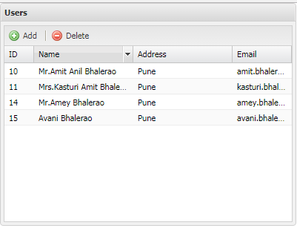

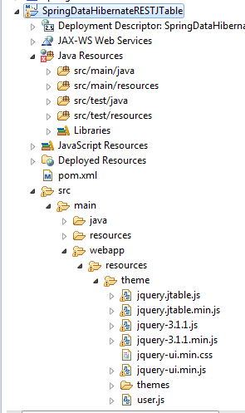
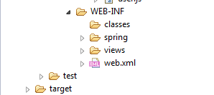

Pom.xml:
<?xml version="1.0" encoding="UTF-8"?>
<project xmlns="http://maven.apache.org/POM/4.0.0" xmlns:xsi="http://www.w3.org/2001/XMLSchema-instance"
xsi:schemaLocation="http://maven.apache.org/POM/4.0.0 http://maven.apache.org/maven-v4_0_0.xsd">
<modelVersion>4.0.0</modelVersion>
<groupId>com.tcs</groupId>
<artifactId>controller</artifactId>
<name>SpringDataHibernateRESTAngularJS</name>
<packaging>war</packaging>
<version>1.0.0-BUILD-SNAPSHOT</version>
<properties>
<java-version>1.8</java-version>
<org.springframework-version>4.0.0.RELEASE</org.springframework-version>
<org.aspectj-version>1.6.10</org.aspectj-version>
<org.slf4j-version>1.6.6</org.slf4j-version>
</properties>
<dependencies>
<dependency>
<groupId>org.springframework</groupId>
<artifactId>spring-context</artifactId>
<version>${org.springframework-version}</version>
<exclusions>
<!-- Exclude Commons Logging in favor of SLF4j -->
<exclusion>
<groupId>commons-logging</groupId>
<artifactId>commons-logging</artifactId>
</exclusion>
</exclusions>
</dependency>
<dependency>
<groupId>org.springframework</groupId>
<artifactId>spring-webmvc</artifactId>
<version>${org.springframework-version}</version>
</dependency>

<!-- AspectJ -->
<dependency>
<groupId>org.aspectj</groupId>
<artifactId>aspectjrt</artifactId>
<version>${org.aspectj-version}</version>
</dependency>

<!-- Logging -->
<dependency>
<groupId>org.slf4j</groupId>
<artifactId>slf4j-api</artifactId>
<version>${org.slf4j-version}</version>
</dependency>
<dependency>
<groupId>org.slf4j</groupId>
<artifactId>jcl-over-slf4j</artifactId>
<version>${org.slf4j-version}</version>
<scope>runtime</scope>
</dependency>
<dependency>
<groupId>org.slf4j</groupId>
<artifactId>slf4j-log4j12</artifactId>
<version>${org.slf4j-version}</version>
<scope>runtime</scope>
</dependency>
<dependency>
<groupId>log4j</groupId>
<artifactId>log4j</artifactId>
<version>1.2.15</version>
<exclusions>
<exclusion>
<groupId>javax.mail</groupId>
<artifactId>mail</artifactId>
</exclusion>
<exclusion>
<groupId>javax.jms</groupId>
<artifactId>jms</artifactId>
</exclusion>
<exclusion>
<groupId>com.sun.jdmk</groupId>
<artifactId>jmxtools</artifactId>
</exclusion>
<exclusion>
<groupId>com.sun.jmx</groupId>
<artifactId>jmxri</artifactId>
</exclusion>
</exclusions>
<scope>runtime</scope>
</dependency>

<!-- @Inject -->
<dependency>
<groupId>javax.inject</groupId>
<artifactId>javax.inject</artifactId>
<version>1</version>
</dependency>

<!-- Servlet -->

<dependency>
<groupId>javax.servlet.jsp</groupId>
<artifactId>jsp-api</artifactId>
<version>2.1</version>
<scope>provided</scope>
</dependency>
<dependency>
<groupId>javax.servlet</groupId>
<artifactId>jstl</artifactId>
<version>1.2</version>
</dependency>

<!-- Test -->
<dependency>
<groupId>junit</groupId>
<artifactId>junit</artifactId>
<version>4.7</version>
<scope>test</scope>
</dependency>

<!-- MySQL database driver -->
<dependency>
<groupId>mysql</groupId>
<artifactId>mysql-connector-java</artifactId>
<version>5.1.9</version>
</dependency>

<!-- Hibernate framework -->
<dependency>
<groupId>org.hibernate</groupId>
<artifactId>hibernate-core</artifactId>
<version>4.2.4.Final</version>
</dependency>

<dependency>
<groupId>org.springframework</groupId>
<artifactId>spring-orm</artifactId>
<version>${org.springframework-version}</version>
</dependency>
<dependency>
<groupId>org.aspectj</groupId>
<artifactId>aspectjrt</artifactId>
<version>${org.aspectj-version}</version>
</dependency>

<dependency>
<groupId>org.springframework</groupId>
<artifactId>spring-web</artifactId>
<version>${org.springframework-version}</version>
</dependency>
<dependency>
<groupId>org.springframework</groupId>
<artifactId>spring-jdbc</artifactId>
<version>${org.springframework-version}</version>
</dependency>

<dependency>
<groupId>com.fasterxml.jackson.core</groupId>
<artifactId>jackson-databind</artifactId>
<version>2.4.1</version>
</dependency>

<dependency>
<groupId>com.sun</groupId>
<artifactId>tools</artifactId>
<version>1.6</version>
<scope>system</scope>
<systemPath>C:\Program Files\Java\jdk1.8.0_131\lib\tools.jar</systemPath>
</dependency>

<!-- Spring Data JPA -->
<dependency>
<groupId>org.springframework.data</groupId>
<artifactId>spring-data-jpa</artifactId>
<version>1.0.2.RELEASE</version>
</dependency>

<dependency>
<groupId>org.hibernate</groupId>
<artifactId>hibernate-entitymanager</artifactId>
<version>4.2.4.Final</version>
</dependency>

</dependencies>
<build>
<finalName>SpringDataHibernateRESTAngularJS</finalName>
<plugins>
<plugin>
<artifactId>maven-eclipse-plugin</artifactId>
<version>2.9</version>
<configuration>
<additionalProjectnatures>
<projectnature>org.springframework.ide.eclipse.core.springnature</projectnature>
</additionalProjectnatures>
<additionalBuildcommands>
<buildcommand>org.springframework.ide.eclipse.core.springbuilder</buildcommand>
</additionalBuildcommands>
<downloadSources>true</downloadSources>
<downloadJavadocs>true</downloadJavadocs>
</configuration>
</plugin>
<plugin>
<groupId>org.apache.maven.plugins</groupId>
<artifactId>maven-compiler-plugin</artifactId>
<version>2.5.1</version>
<configuration>
<source>1.6</source>
<target>1.6</target>
<compilerArgument>-Xlint:all</compilerArgument>
<showWarnings>true</showWarnings>
<showDeprecation>true</showDeprecation>
</configuration>
</plugin>
<plugin>
<groupId>org.codehaus.mojo</groupId>
<artifactId>exec-maven-plugin</artifactId>
<version>1.2.1</version>
<configuration>
<mainClass>org.test.int1.Main</mainClass>
</configuration>
</plugin>
</plugins>
</build>
</project>

Web.xml:
<?xml version="1.0" encoding="UTF-8"?>
<web-app xmlns:xsi="http://www.w3.org/2001/XMLSchema-instance"
xmlns="http://java.sun.com/xml/ns/javaee"
xsi:schemaLocation="http://java.sun.com/xml/ns/javaee http://java.sun.com/xml/ns/javaee/web-app_2_5.xsd"
version="2.5">
<context-param>
<param-name>contextConfigLocation</param-name>
<param-value>/WEB-INF/spring/root-context.xml</param-value>
</context-param>
<listener>
<listener-class>org.springframework.web.context.ContextLoaderListener</listener-class>
</listener>
<servlet>
<servlet-name>appServlet</servlet-name>
<servlet-class>org.springframework.web.servlet.DispatcherServlet</servlet-class>
<init-param>
<param-name>contextConfigLocation</param-name>
<param-value>/WEB-INF/spring/appServlet/servlet-context.xml</param-value>
</init-param>
<load-on-startup>1</load-on-startup>
</servlet>
<servlet-mapping>
<servlet-name>appServlet</servlet-name>
<url-pattern>/</url-pattern>
</servlet-mapping>
</web-app>
app.properties:
app.jdbc.driverClassName=com.mysql.jdbc.Driver
app.jdbc.url=jdbc:mysql://localhost:3306/hibernate
app.jdbc.username=root
app.jdbc.password=

Servlet-context.xml:
<?xml version="1.0" encoding="UTF-8"?>
<beans:beans xmlns="http://www.springframework.org/schema/mvc"
xmlns:jpa="http://www.springframework.org/schema/data/jpa"
xmlns:xsi="http://www.w3.org/2001/XMLSchema-instance" xmlns:beans="http://www.springframework.org/schema/beans"
xmlns:p="http://www.springframework.org/schema/p"
xmlns:context="http://www.springframework.org/schema/context" xmlns:tx="http://www.springframework.org/schema/tx"
xsi:schemaLocation="http://www.springframework.org/schema/mvc http://www.springframework.org/schema/mvc/spring-mvc.xsd
http://www.springframework.org/schema/beans http://www.springframework.org/schema/beans/spring-beans.xsd
http://www.springframework.org/schema/tx http://www.springframework.org/schema/tx/spring-tx.xsd
http://www.springframework.org/schema/data/jpa http://www.springframework.org/schema/data/jpa/spring-jpa-1.0.xsd
http://www.springframework.org/schema/context http://www.springframework.org/schema/context/spring-context.xsd">

<annotation-driven />

<context:property-placeholder location="classpath:app.properties" />
<context:component-scan base-package="com.technicalkeeda" />

<resources mapping="/resources/**" location="/resources/theme/" />

<beans:bean class="org.springframework.web.servlet.view.InternalResourceViewResolver">
<beans:property name="prefix" value="/WEB-INF/views/" />
<beans:property name="suffix" value=".jsp" />
</beans:bean>

<beans:bean id="dataSource"
class="org.springframework.jdbc.datasource.DriverManagerDataSource">
<beans:property name="driverClassName" value="${app.jdbc.driverClassName}" />
<beans:property name="url" value="${app.jdbc.url}" />
<beans:property name="username" value="${app.jdbc.username}" />
<beans:property name="password" value="${app.jdbc.password}" />
</beans:bean>

<beans:bean id="transactionManager" class="org.springframework.orm.jpa.JpaTransactionManager">
<beans:property name="entityManagerFactory" ref="entityManagerFactory"/>
</beans:bean>

<tx:annotation-driven/>

<beans:bean id="hibernateJpaVendorAdapter" class="org.springframework.orm.jpa.vendor.HibernateJpaVendorAdapter"/>

<beans:bean id="entityManagerFactory" class="org.springframework.orm.jpa.LocalContainerEntityManagerFactoryBean">
<beans:property name="dataSource" ref="dataSource"/>
<beans:property name="jpaVendorAdapter" ref="hibernateJpaVendorAdapter"/>
<beans:property name="packagesToScan" value="com.technicalkeeda.bean"/>
<beans:property name="jpaProperties">
<beans:props>
<beans:prop key="hibernate.dialect">org.hibernate.dialect.MySQLDialect</beans:prop>
<beans:prop key="hibernate.hbm2ddl.auto">update</beans:prop>
<beans:prop key="hibernate.ejb.naming_strategy">org.hibernate.cfg.ImprovedNamingStrategy</beans:prop>
<beans:prop key="hibernate.show_sql">true</beans:prop>
<beans:prop key="hibernate.format_sql">true</beans:prop>
</beans:props>
</beans:property>
</beans:bean>

<jpa:repositories base-package="com.technicalkeeda.repository"/>
</beans:beans>

User.java:
package com.technicalkeeda.bean;

import javax.persistence.Column;
import javax.persistence.Entity;
import javax.persistence.GeneratedValue;
import javax.persistence.GenerationType;
import javax.persistence.Id;
import javax.persistence.Table;

import com.fasterxml.jackson.annotation.JsonIgnoreProperties;

@Entity
@Table(name = "users")
@JsonIgnoreProperties(ignoreUnknown = true)
public class User {
@Id
@GeneratedValue(strategy = GenerationType.IDENTITY)
private int id;
@Column
private String username;
@Column
private String address;
@Column
private String email;

public int getId() {
return id;
}

public void setId(int id) {
this.id = id;
}

public String getUsername() {
return username;
}

public void setUsername(String username) {
this.username = username;
}

public String getAddress() {
return address;
}

public void setAddress(String address) {
this.address = address;
}

public String getEmail() {
return email;
}

public void setEmail(String email) {
this.email = email;
}

@Override
public int hashCode() {
final int prime = 31;
int result = 1;
result = prime * result + (int) (id ^ (id >>> 32));
return result;
}

@Override
public boolean equals(Object obj) {
if (this == obj)
return true;
if (obj == null)
return false;
if (!(obj instanceof User))
return false;
User other = (User) obj;
if (id != other.id)
return false;
return true;
}

@Override
public String toString() {
return "User [id=" + id + ", username=" + username + ", address="
+ address + ", email=" + email + "]";
}

}

UserRepository.java:
package com.technicalkeeda.repository;

import org.springframework.data.jpa.repository.JpaRepository;
import com.technicalkeeda.bean.User;

public interface UserRepository extends JpaRepository<User, Integer>{
}
UserService.java:
package com.technicalkeeda.service;

import java.util.List;
import com.technicalkeeda.bean.User;

public interface UserService {

public User findById(int id);

public User saveUser(User user);

public User updateUser(User user);

public User deleteUserById(int id);

public List<User> findAllUsers();

}

UserServiceImpl.java:
package com.technicalkeeda.service;

import java.util.List;
import javax.annotation.Resource;
import javax.persistence.EntityManager;
import javax.persistence.PersistenceContext;
import org.springframework.stereotype.Service;
import org.springframework.transaction.annotation.Transactional;
import com.technicalkeeda.bean.User;
import com.technicalkeeda.repository.UserRepository;

@Service("userService")
public class UserServiceImpl implements UserService {

@Resource
private UserRepository userRepository;

@PersistenceContext
EntityManager entityManager;

@Override
public User findById(int id) {
return userRepository.findOne(id);
}

@Override
public User saveUser(User user) {
User createdUser = user;
return userRepository.save(createdUser);
}

@Override
@Transactional
public User updateUser(User user) {
User updatedUser = userRepository.findOne(user.getId());
updatedUser.setId(user.getId());
updatedUser.setUsername(user.getUsername());
updatedUser.setAddress(user.getAddress());
updatedUser.setEmail(user.getEmail());
System.out.println("Updated User Details:");
System.out.println(updatedUser.getId() + "\t"
+ updatedUser.getUsername() + "\t" + updatedUser.getAddress()
+ "\t" + updatedUser.getEmail());
return updatedUser;
}

@Override
public User deleteUserById(int id) {
User deletedUser = userRepository.findOne(id);
userRepository.delete(deletedUser);
return deletedUser;
}

@Override
public List<User> findAllUsers() {
return userRepository.findAll();
}

}
UserController.java:
package com.technicalkeeda.controller;

import java.util.HashMap;
import java.util.Locale;
import java.util.Map;
import org.springframework.beans.factory.annotation.Autowired;
import org.springframework.http.HttpStatus;
import org.springframework.http.MediaType;
import org.springframework.http.ResponseEntity;
import org.springframework.stereotype.Controller;
import org.springframework.ui.Model;
import org.springframework.web.bind.annotation.ModelAttribute;
import org.springframework.web.bind.annotation.RequestMapping;
import org.springframework.web.bind.annotation.RequestMethod;
import com.technicalkeeda.bean.User;
import com.technicalkeeda.service.UserService;

@Controller
public class UserController {

@Autowired
UserService userService; //Service which will do all data retrieval/manipulation work

@RequestMapping(value = "/", method = RequestMethod.GET)
public String loginPage(Locale locale, Model model) {
return "users";
}

@RequestMapping(value = "/get", method = RequestMethod.GET, produces = MediaType.APPLICATION_JSON_VALUE)
public ResponseEntity<Map<String, Object>> getAllUsers() {
Map<String, Object> resultMap = new HashMap<>();
resultMap.put("Result", "OK");
resultMap.put("Records", userService.findAllUsers());
return new ResponseEntity<Map<String, Object>>(resultMap, HttpStatus.OK);
}

@RequestMapping(value = "/save-edit", method = RequestMethod.POST, consumes = MediaType.APPLICATION_FORM_URLENCODED_VALUE, produces = MediaType.APPLICATION_JSON_VALUE)
public ResponseEntity<Map<String, Object>> saveUser(@ModelAttribute User user) {
userService.saveUser(user);
Map<String, Object> resultMap = new HashMap<>();
resultMap.put("Result", "OK");
resultMap.put("Record", user);
return new ResponseEntity<Map<String, Object>>(resultMap, HttpStatus.OK);

}

@RequestMapping(value = "/delete", method = RequestMethod.POST)
public ResponseEntity<Map<String, Object>> deleteEmployee(Integer userid) {
userService.deleteUserById(userid);
Map<String, Object> resultMap = new HashMap<>();
resultMap.put("Result", "OK");
return new ResponseEntity<Map<String, Object>>(resultMap, HttpStatus.OK);

}
}

users.jsp:
<%@ page language="java" contentType="text/html; charset=ISO-8859-1" pageEncoding="ISO-8859-1"%>
<%@ taglib prefix="c" uri="http://java.sun.com/jsp/jstl/core" %>

<!DOCTYPE html PUBLIC "-//W3C//DTD HTML 4.01 Transitional//EN" "http://www.w3.org/TR/html4/loose.dtd">
<html>
<head>
<meta http-equiv="Content-Type" content="text/html; charset=ISO-8859-1">

<link href="<c:url value='resources/themes/lightcolor/orange/jtable.css' />" rel="stylesheet" type="text/css" />
<link href="<c:url value='resources/jquery-ui.min.css' />" rel="stylesheet" type="text/css" />

<script type="text/javascript" src="<c:url value='resources/jquery-3.1.1.min.js' />"></script>
<script type="text/javascript" src="<c:url value='resources/jquery-ui.min.js' />"></script>
<script type="text/javascript" src="<c:url value='resources/jquery.jtable.min.js' />" ></script>
<script type="text/javascript" src="<c:url value='resources/jquery.jtable.js' />"></script>
<script type="text/javascript" src="<c:url value='resources/user.js' />"></script>
</head>
<body>
<div id="userResultsDiv"></div>
</body>
</html>

users.js:
$(document).ready(function() {
$('#userResultsDiv').jtable({
title :'List of Employees',
actions : {
// listAction : 'get',
listAction : function (postData, jtParams) {
return $.Deferred(function ($dfd) {
$.ajax({
url: 'get',
type: 'GET',
dataType: 'json',
data: postData,
success: function (data) {
$dfd.resolve(data);
},
error: function () {
$dfd.reject();
}
});
});
},
createAction : 'save-edit',
updateAction : 'save-edit',
deleteAction : 'delete'
},
fields : {
id : {
title : 'User ID',
key : true,
width : '15%'
},
username : {
title : 'Username',
width : '30%',
type : 'hidden-edit'
},
address : {
title : 'Address',
width : '15%'
},
email : {
title : 'Email',
width : '25%'
}
}
});
$('#userResultsDiv').jtable('load');
});
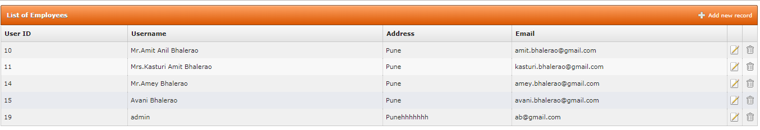
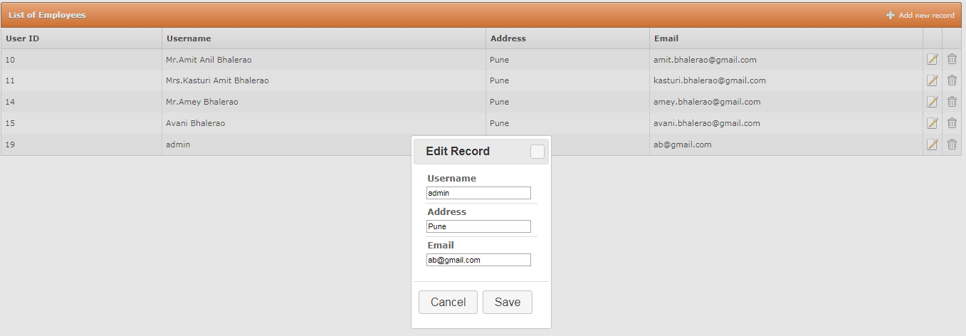

Project Structure:
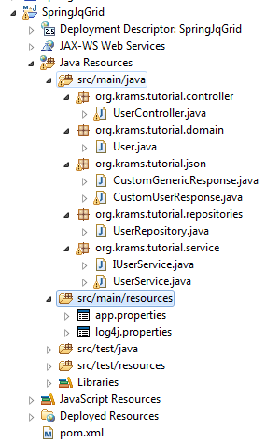
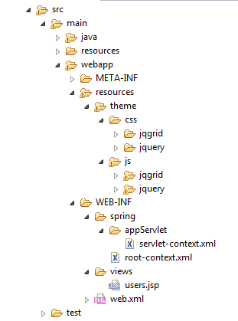
Pom.xml:
<project xmlns="http://maven.apache.org/POM/4.0.0" xmlns:xsi="http://www.w3.org/2001/XMLSchema-instance"
xsi:schemaLocation="http://maven.apache.org/POM/4.0.0 http://maven.apache.org/maven-v4_0_0.xsd">
<modelVersion>4.0.0</modelVersion>
<groupId>org.krams.tutorial</groupId>
<artifactId>SpringJQGrid</artifactId>
<packaging>war</packaging>
<version>1.0.0-SNAPSHOT</version>
<name>SpringJQGrid Maven Webapp</name>
<url>http://maven.apache.org</url>
<properties>
<java-version>1.6</java-version>
<org.springframework-version>4.0.0.RELEASE</org.springframework-version>
<org.aspectj-version>1.6.10</org.aspectj-version>
<org.slf4j-version>1.6.6</org.slf4j-version>
</properties>
<dependencies>
<dependency>
<groupId>org.springframework</groupId>
<artifactId>spring-context</artifactId>
<version>${org.springframework-version}</version>
<exclusions>
<!-- Exclude Commons Logging in favor of SLF4j -->
<exclusion>
<groupId>commons-logging</groupId>
<artifactId>commons-logging</artifactId>
</exclusion>
</exclusions>
</dependency>
<dependency>
<groupId>org.springframework</groupId>
<artifactId>spring-webmvc</artifactId>
<version>${org.springframework-version}</version>
</dependency>

<!-- AspectJ -->
<dependency>
<groupId>org.aspectj</groupId>
<artifactId>aspectjrt</artifactId>
<version>${org.aspectj-version}</version>
</dependency>

<!-- Logging -->
<dependency>
<groupId>org.slf4j</groupId>
<artifactId>slf4j-api</artifactId>
<version>${org.slf4j-version}</version>
</dependency>
<dependency>
<groupId>org.slf4j</groupId>
<artifactId>jcl-over-slf4j</artifactId>
<version>${org.slf4j-version}</version>
<scope>runtime</scope>
</dependency>
<dependency>
<groupId>org.slf4j</groupId>
<artifactId>slf4j-log4j12</artifactId>
<version>${org.slf4j-version}</version>
<scope>runtime</scope>
</dependency>

<dependency>
<groupId>log4j</groupId>
<artifactId>log4j</artifactId>
<version>1.2.14</version>
<type>jar</type>
<scope>compile</scope>
</dependency>

<dependency>
<groupId>org.codehaus.jackson</groupId>
<artifactId>jackson-core-asl</artifactId>
<version>1.6.3</version>
<type>jar</type>
<scope>compile</scope>
</dependency>

<dependency>
<groupId>taglibs</groupId>
<artifactId>standard</artifactId>
<version>1.1.2</version>
<type>jar</type>
<scope>compile</scope>
</dependency>

<dependency>
<groupId>org.codehaus.jackson</groupId>
<artifactId>jackson-jaxrs</artifactId>
<version>1.6.3</version>
<type>jar</type>
<scope>compile</scope>
</dependency>

<!-- @Inject -->
<dependency>
<groupId>javax.inject</groupId>
<artifactId>javax.inject</artifactId>
<version>1</version>
</dependency>

<!-- Servlet -->

<dependency>
<groupId>javax.servlet.jsp</groupId>
<artifactId>jsp-api</artifactId>
<version>2.1</version>
<scope>provided</scope>
</dependency>
<dependency>
<groupId>javax.servlet</groupId>
<artifactId>jstl</artifactId>
<version>1.2</version>
</dependency>

<!-- Test -->
<dependency>
<groupId>junit</groupId>
<artifactId>junit</artifactId>
<version>4.7</version>
<scope>test</scope>
</dependency>

<!-- MySQL database driver -->
<dependency>
<groupId>mysql</groupId>
<artifactId>mysql-connector-java</artifactId>
<version>5.1.9</version>
</dependency>

<!-- Hibernate framework -->
<dependency>
<groupId>org.hibernate</groupId>
<artifactId>hibernate-core</artifactId>
<version>4.2.4.Final</version>
</dependency>

<dependency>
<groupId>org.springframework</groupId>
<artifactId>spring-orm</artifactId>
<version>${org.springframework-version}</version>
</dependency>
<dependency>
<groupId>org.aspectj</groupId>
<artifactId>aspectjrt</artifactId>
<version>${org.aspectj-version}</version>
</dependency>

<dependency>
<groupId>org.springframework</groupId>
<artifactId>spring-web</artifactId>
<version>${org.springframework-version}</version>
</dependency>
<dependency>
<groupId>org.springframework</groupId>
<artifactId>spring-jdbc</artifactId>
<version>${org.springframework-version}</version>
</dependency>

<!-- Tiles dependencies -->
<dependency>
<groupId>org.apache.tiles</groupId>
<artifactId>tiles-api</artifactId>
<version>2.2.2</version>
</dependency>

<dependency>
<groupId>org.apache.tiles</groupId>
<artifactId>tiles-autotag-core-runtime</artifactId>
<version>1.1.0</version>
</dependency>

<dependency>
<groupId>org.apache.tiles</groupId>
<artifactId>tiles-core</artifactId>
<version>2.2.2</version>
</dependency>

<dependency>
<groupId>org.apache.tiles</groupId>
<artifactId>tiles-jsp</artifactId>
<version>2.2.2</version>
</dependency>

<dependency>
<groupId>org.apache.tiles</groupId>
<artifactId>tiles-servlet</artifactId>
<version>2.2.2</version>
</dependency>

<dependency>
<groupId>org.apache.tiles</groupId>
<artifactId>tiles-template</artifactId>
<version>2.2.2</version>
</dependency>

<dependency>
<groupId>com.fasterxml.jackson.core</groupId>
<artifactId>jackson-databind</artifactId>
<version>2.4.1</version>
</dependency>

<!-- Spring Data JPA -->
<dependency>
<groupId>org.springframework.data</groupId>
<artifactId>spring-data-jpa</artifactId>
<version>1.0.2.RELEASE</version>
</dependency>

<dependency>
<groupId>org.hibernate</groupId>
<artifactId>hibernate-entitymanager</artifactId>
<version>4.2.4.Final</version>
</dependency>

<dependency>
<groupId>com.sun</groupId>
<artifactId>tools</artifactId>
<version>1.6</version>
<scope>system</scope>
<systemPath>C:\Program Files\Java\jdk1.8.0_131\lib\tools.jar</systemPath>
</dependency>

</dependencies>
<build>
<finalName>SpringJQGrid</finalName>
<plugins>
<plugin>
<groupId>org.apache.maven.plugins</groupId>
<artifactId>maven-compiler-plugin</artifactId>
<configuration>
<source>1.5</source>
<target>1.5</target>
</configuration>
</plugin>
</plugins>
</build>
</project>

Web.xml:
<?xml version="1.0" encoding="UTF-8"?>
<web-app xmlns:xsi="http://www.w3.org/2001/XMLSchema-instance"
xmlns="http://java.sun.com/xml/ns/javaee"
xsi:schemaLocation="http://java.sun.com/xml/ns/javaee http://java.sun.com/xml/ns/javaee/web-app_2_5.xsd"
version="2.5">
<context-param>
<param-name>contextConfigLocation</param-name>
<param-value>/WEB-INF/spring/root-context.xml</param-value>
</context-param>
<listener>
<listener-class>org.springframework.web.context.ContextLoaderListener</listener-class>
</listener>
<servlet>
<servlet-name>appServlet</servlet-name>
<servlet-class>org.springframework.web.servlet.DispatcherServlet</servlet-class>
<init-param>
<param-name>contextConfigLocation</param-name>
<param-value>/WEB-INF/spring/appServlet/servlet-context.xml</param-value>
</init-param>
<load-on-startup>1</load-on-startup>
</servlet>
<servlet-mapping>
<servlet-name>appServlet</servlet-name>
<url-pattern>/</url-pattern>
</servlet-mapping>
</web-app>
Servlet-context.xml:
<?xml version="1.0" encoding="UTF-8"?>
<beans:beans xmlns="http://www.springframework.org/schema/mvc"
xmlns:jpa="http://www.springframework.org/schema/data/jpa" xmlns:xsi="http://www.w3.org/2001/XMLSchema-instance"
xmlns:beans="http://www.springframework.org/schema/beans" xmlns:p="http://www.springframework.org/schema/p"
xmlns:context="http://www.springframework.org/schema/context" xmlns:tx="http://www.springframework.org/schema/tx"
xsi:schemaLocation="http://www.springframework.org/schema/mvc http://www.springframework.org/schema/mvc/spring-mvc.xsd
http://www.springframework.org/schema/beans http://www.springframework.org/schema/beans/spring-beans.xsd
http://www.springframework.org/schema/tx http://www.springframework.org/schema/tx/spring-tx.xsd
http://www.springframework.org/schema/data/jpa http://www.springframework.org/schema/data/jpa/spring-jpa-1.0.xsd
http://www.springframework.org/schema/context http://www.springframework.org/schema/context/spring-context.xsd">

<annotation-driven />

<context:property-placeholder location="classpath:app.properties" />
<context:component-scan base-package="org.krams.tutorial" />

<resources mapping="/resources/**" location="/resources/theme/" />

<beans:bean
class="org.springframework.web.servlet.view.InternalResourceViewResolver">
<beans:property name="prefix" value="/WEB-INF/views/" />
<beans:property name="suffix" value=".jsp" />
</beans:bean>

<beans:bean id="dataSource"
class="org.springframework.jdbc.datasource.DriverManagerDataSource">
<beans:property name="driverClassName" value="${app.jdbc.driverClassName}" />
<beans:property name="url" value="${app.jdbc.url}" />
<beans:property name="username" value="${app.jdbc.username}" />
<beans:property name="password" value="${app.jdbc.password}" />
</beans:bean>

<beans:bean id="transactionManager"
class="org.springframework.orm.jpa.JpaTransactionManager">
<beans:property name="entityManagerFactory" ref="entityManagerFactory" />
</beans:bean>

<tx:annotation-driven />

<beans:bean id="hibernateJpaVendorAdapter"
class="org.springframework.orm.jpa.vendor.HibernateJpaVendorAdapter" />

<!-- Creates the bean that creates the JPA entity manager factory. -->
<beans:bean id="entityManagerFactory"
class="org.springframework.orm.jpa.LocalContainerEntityManagerFactoryBean">
<beans:property name="dataSource" ref="dataSource" />
<beans:property name="jpaVendorAdapter" ref="hibernateJpaVendorAdapter" />
<beans:property name="packagesToScan" value="org.krams.tutorial.domain" />
<beans:property name="jpaProperties">
<beans:props>
<beans:prop key="hibernate.dialect">org.hibernate.dialect.MySQLDialect
</beans:prop>
<beans:prop key="hibernate.hbm2ddl.auto">update</beans:prop>
<beans:prop key="hibernate.ejb.naming_strategy">org.hibernate.cfg.ImprovedNamingStrategy
</beans:prop>
<beans:prop key="hibernate.show_sql">true</beans:prop>
<beans:prop key="hibernate.format_sql">true</beans:prop>
</beans:props>
</beans:property>
</beans:bean>

<jpa:repositories base-package="org.krams.tutorial.repositories" />
</beans:beans>

app.properties:
app.jdbc.driverClassName=com.mysql.jdbc.Driver
app.jdbc.url=jdbc:mysql://localhost:3306/hibernate
app.jdbc.username=root
app.jdbc.password=

User.java:
package org.krams.tutorial.domain;

import javax.persistence.Column;
import javax.persistence.Entity;
import javax.persistence.GeneratedValue;
import javax.persistence.GenerationType;
import javax.persistence.Id;
import javax.persistence.Table;
import com.fasterxml.jackson.annotation.JsonIgnoreProperties;

@Entity
@Table(name = "users")
@JsonIgnoreProperties(ignoreUnknown = true)
public class User {
@Id
@GeneratedValue(strategy = GenerationType.IDENTITY)
private int id;
@Column
private String username;
@Column
private String address;
@Column
private String email;

public int getId() {
return id;
}

public void setId(int id) {
this.id = id;
}

public String getUsername() {
return username;
}

public void setUsername(String username) {
this.username = username;
}

public String getAddress() {
return address;
}

public void setAddress(String address) {
this.address = address;
}

public String getEmail() {
return email;
}

public void setEmail(String email) {
this.email = email;
}

@Override
public int hashCode() {
final int prime = 31;
int result = 1;
result = prime * result + (int) (id ^ (id >>> 32));
return result;
}

@Override
public boolean equals(Object obj) {
if (this == obj)
return true;
if (obj == null)
return false;
if (!(obj instanceof User))
return false;
User other = (User) obj;
if (id != other.id)
return false;
return true;
}

@Override
public String toString() {
return "User [id=" + id + ", username=" + username + ", address="
+ address + ", email=" + email + "]";
}
}

CustomGenericResponse.java:
package org.krams.tutorial.json;

import java.util.ArrayList;
import java.util.List;

/**
* A custom POJO that will be automatically converted to JSON format.
* <p>We can use this to send generic messages to our JqGrid, whether a request is successful or not.
* Of course, you will use plain JavaScript to parse the JSON response.
*/
public class CustomGenericResponse {

/**
* true if successful.
*/
private Boolean success;

/**
* Any custom message, i.e, 'Your request has been processed successfully!'
*/
private List<String> message;

public CustomGenericResponse() {
message = new ArrayList<String>();
}

public Boolean getSuccess() {
return success;
}

public void setSuccess(Boolean success) {
this.success = success;
}

public List<String> getMessage() {
return message;
}

public void setMessage(String message) {
this.message.add(message);
}

}

CustomUserResponse.java:
package org.krams.tutorial.json;

import java.util.List;

import org.krams.tutorial.domain.User;

/**
* A simple POJO that maps to the JSON structure of a JqGrid.
* <p>The property names of this POJO must match the property names of your JqGrid's jsonReader.
*
* @see <a href="http://www.trirand.com/jqgridwiki/doku.php?id=wiki:retrieving_data#json_data">JSON Data</a>
*
*/
public class CustomUserResponse {

/**
* Current page of the query
*/
private String page;

/**
* Total pages for the query
*/
private String total;

/**
* Total number of records for the query
*/
private String records;

/**
* An array that contains the actual objects
*/
private List<User> rows;

public CustomUserResponse() {
}

public String getPage() {
return page;
}

public void setPage(String page) {
this.page = page;
}

public String getTotal() {
return total;
}

public void setTotal(String total) {
this.total = total;
}

public String getRecords() {
return records;
}

public void setRecords(String records) {
this.records = records;
}

public List<User> getRows() {
return rows;
}

public void setRows(List<User> rows) {
this.rows = rows;
}

}

UserRepository.java:
package org.krams.tutorial.repositories;

import org.springframework.data.jpa.repository.JpaRepository;
import org.krams.tutorial.domain.User;

public interface UserRepository extends JpaRepository<User, Integer>{
}
IUserService.java
package org.krams.tutorial.service;

import java.util.List;
import org.krams.tutorial.domain.User;

public interface IUserService {
public List<User> getAll();

public User get(int id);

public User add(User user);

public User delete(int id);

public User edit(User user);
}
UserService.java:
package org.krams.tutorial.service;

import java.util.List;
import javax.annotation.Resource;
import org.apache.log4j.Logger;
import org.krams.tutorial.domain.User;
import org.krams.tutorial.repositories.UserRepository;
import org.springframework.stereotype.Service;
import org.springframework.transaction.annotation.Transactional;

@Service("userService")
@Transactional
public class UserService implements IUserService {

protected static Logger logger = Logger.getLogger("service");

@Resource
private UserRepository userRepository;

public List<User> getAll() {
logger.debug("Retrieving all users");
return userRepository.findAll();
}

public User get(int id ) {
logger.debug("Retrieving an existing user");
return userRepository.findOne(id);
}

public User add( User user ) {
logger.debug("Adding a new user");
User createdUser = user;
return userRepository.save(createdUser);
}

public User delete(int id) {
logger.debug("Deleting an existing user");
User deletedUser = userRepository.findOne(id);
userRepository.delete(deletedUser);
return deletedUser;

}

public User edit( User user ) {
logger.debug("Editing an existing user");
User updatedUser = userRepository.findOne(user.getId());
updatedUser.setId(user.getId());
updatedUser.setUsername(user.getUsername());
updatedUser.setAddress(user.getAddress());
updatedUser.setEmail(user.getEmail());
System.out.println("Updated User Details:");
System.out.println(updatedUser.getId()+"\t"+updatedUser.getUsername() + "\t"
+ updatedUser.getAddress() + "\t"
+ updatedUser.getEmail());
return updatedUser;

}

}

users.jsp:
<%@ taglib uri="http://java.sun.com/jsp/jstl/core" prefix="c" %>
<%@ taglib uri="http://www.springframework.org/tags/form" prefix="form" %>

<!DOCTYPE html PUBLIC "-//W3C//DTD XHTML 1.0 Transitional//EN" "http://www.w3.org/TR/xhtml1/DTD/xhtml1-transitional.dtd">
<html xmlns="http://www.w3.org/1999/xhtml">

<head>
<link rel="stylesheet" type="text/css" media="screen" href="<c:url value='/resources/css/jquery/ui-lightness/jquery-ui-1.8.6.custom.css' />" />
<link rel="stylesheet" type="text/css" media="screen" href="<c:url value='/resources/css/jqgrid/ui.jqgrid.css' />" />

<script type="text/javascript" src="<c:url value='/resources/js/jquery/jquery-1.4.4.min.js' />"></script>
<script type="text/javascript">
var jq = jQuery.noConflict();
</script>
<script type="text/javascript" src="<c:url value='/resources/js/jquery/jquery-ui-1.8.6.custom.min.js' />"></script>
<script type="text/javascript" src="<c:url value='/resources/js/jqgrid/grid.locale-en.js' />" ></script>
<script type="text/javascript" src="<c:url value='/resources/js/jqgrid/jquery.jqGrid.min.js' />"></script>

<meta http-equiv="Content-Type" content="text/html; charset=UTF-8" />
<title>JqGrid - Spring 3 MVC Integration Tutorial</title>

</head>

<body >

<script type="text/javascript">
jq(function() {
jq("#grid").jqGrid({
url:'/SpringJQGrid/crud',
datatype: 'json',
mtype: 'GET',
colNames:['Id', 'Username', 'Address','Email'],
colModel:[
{name:'id',index:'id', width:55,editable:false,editoptions:{readonly:true,size:10},hidden:true},
{name:'username',index:'username', width:100,editable:true, editrules:{required:true}, editoptions:{size:10}},
{name:'address',index:'address', width:100,editable:true, editrules:{required:true}, editoptions:{size:10}},
{name:'email',index:'email', width:100,editable:true, editrules:{required:true}, editoptions:{size:10}}
],
postData: {
},
rowNum:20,
rowList:[20,40,60],
height: 200,
autowidth: true,
rownumbers: true,
pager: '#pager',
sortname: 'id',
viewrecords: true,
sortorder: "asc",
caption:"Users",
emptyrecords: "Empty records",
loadonce: false,
loadComplete: function() {
},
jsonReader : {
root: "rows",
page: "page",
total: "total",
records: "records",
repeatitems: false,
cell: "cell",
id: "id"
}
});
jq("#grid").jqGrid('navGrid','#pager',
{edit:false,add:false,del:false,search:true},
{ },
{ },
{ },
{
sopt:['eq', 'ne', 'lt', 'gt', 'cn', 'bw', 'ew'],
closeOnEscape: true,
multipleSearch: true,
closeAfterSearch: true }
);

jq("#grid").navButtonAdd('#pager',
{ caption:"Add",
buttonicon:"ui-icon-plus",
onClickButton: addRow,
position: "last",
title:"",
cursor: "pointer"
}
);

jq("#grid").navButtonAdd('#pager',
{ caption:"Edit",
buttonicon:"ui-icon-pencil",
onClickButton: editRow,
position: "last",
title:"",
cursor: "pointer"
}
);

jq("#grid").navButtonAdd('#pager',
{ caption:"Delete",
buttonicon:"ui-icon-trash",
onClickButton: deleteRow,
position: "last",
title:"",
cursor: "pointer"
}
);

jq("#btnFilter").click(function(){
jq("#grid").jqGrid('searchGrid',
{multipleSearch: false,
sopt:['eq']}
);
});

// Toolbar Search
jq("#grid").jqGrid('filterToolbar',{stringResult: true,searchOnEnter : true, defaultSearch:"cn"});

});
</script>

<script type="text/javascript">

function addRow() {

// Get the currently selected row
jq("#grid").jqGrid('editGridRow','new',
{ url: "/SpringJQGrid/crud/add",
editData: {
},
recreateForm: true,
beforeShowForm: function(form) {
},
closeAfterAdd: true,
reloadAfterSubmit:false,
afterSubmit : function(response, postdata)
{
var result = eval('(' + response.responseText + ')');
var errors = "";

if (result.success == false) {
for (var i = 0; i < result.message.length; i++) {
errors += result.message[i] + "<br/>";
}
} else {
jq("#dialog").text('Entry has been added successfully');
jq("#dialog").dialog(
{ title: 'Success',
modal: true,
buttons: {"Ok": function() {
jq(this).dialog("close");}
}
});
}
// only used for adding new records
var new_id = null;

return [result.success, errors, new_id];
}
});

}

function editRow() {
// Get the currently selected row
var row = jq("#grid").jqGrid('getGridParam','selrow');

if( row != null )
jq("#grid").jqGrid('editGridRow',row,
{ url: "/SpringJQGrid/crud/edit",
editData: {
},
recreateForm: true,
beforeShowForm: function(form) {
},
closeAfterEdit: true,
reloadAfterSubmit:false,
afterSubmit : function(response, postdata)
{
var result = eval('(' + response.responseText + ')');
var errors = "";

if (result.success == false) {
for (var i = 0; i < result.message.length; i++) {
errors += result.message[i] + "<br/>";
}
} else {
jq("#dialog").text('Entry has been edited successfully');
jq("#dialog").dialog(
{ title: 'Success',
modal: true,
buttons: {"Ok": function() {
jq(this).dialog("close");}
}
});
}

return [result.success, errors, null];
}
});
else jq( "#dialogSelectRow" ).dialog();
}

function deleteRow() {
// Get the currently selected row
var row = jq("#grid").jqGrid('getGridParam','selrow');

// A pop-up dialog will appear to confirm the selected action
if( row != null )
jq("#grid").jqGrid( 'delGridRow', row,
{ url: '/SpringJQGrid/crud/delete',
recreateForm: true,
beforeShowForm: function(form) {
//change title
jq(".delmsg").replaceWith('<span style="white-space: pre;">' +
'Delete selected record?' + '</span>');

//hide arrows
jq('#pData').hide();
jq('#nData').hide();
},
reloadAfterSubmit:false,
closeAfterDelete: true,
afterSubmit : function(response, postdata)
{
var result = eval('(' + response.responseText + ')');
var errors = "";

if (result.success == false) {
for (var i = 0; i < result.message.length; i++) {
errors += result.message[i] + "<br/>";
}
} else {
jq("#dialog").text('Entry has been deleted successfully');
jq("#dialog").dialog(
{ title: 'Success',
modal: true,
buttons: {"Ok": function() {
jq(this).dialog("close");}
}
});
}
// only used for adding new records
var new_id = null;

return [result.success, errors, new_id];
}
});
else jq( "#dialogSelectRow" ).dialog();
}

</script>

<div id="jqgrid">
<table id="grid"></table>
<div id="pager"></div>
</div>

<div id="dialog" title="Feature not supported" style="display:none">
<p>That feature is not supported.</p>
</div>

<div id="dialogSelectRow" title="Warning" style="display:none">
<p>Please select row</p>
</div>

</body>

</html>

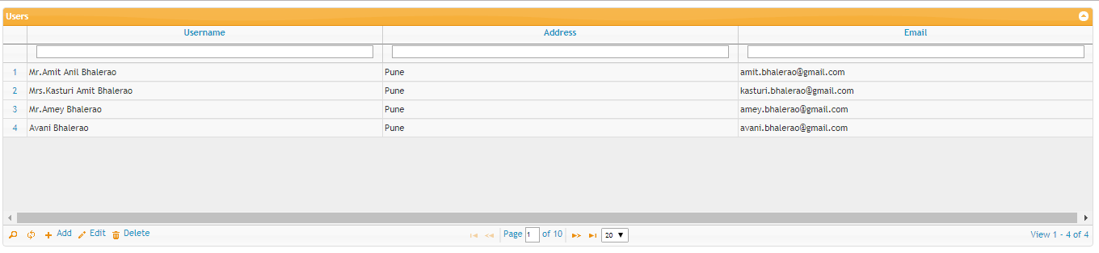
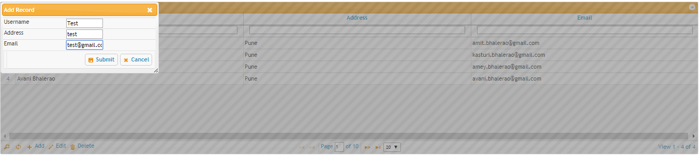
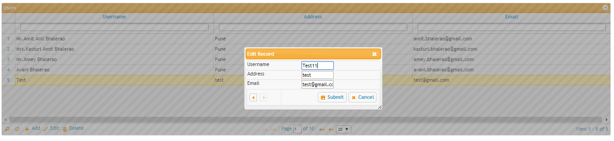
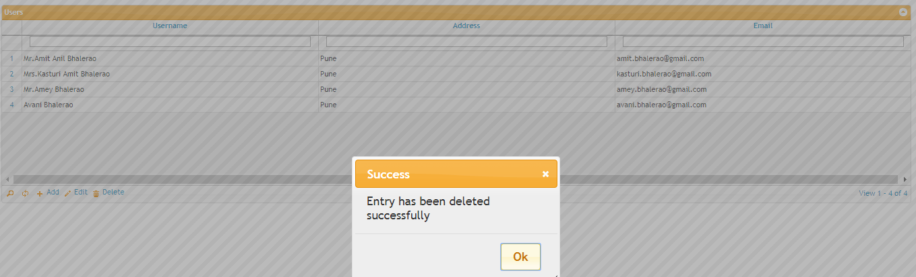

Project Structure:
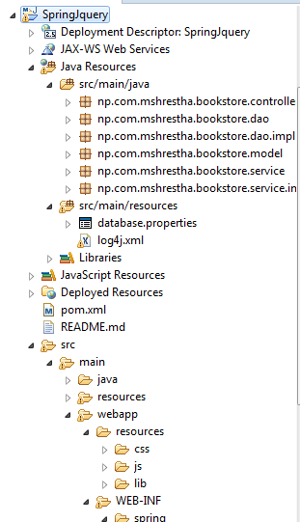
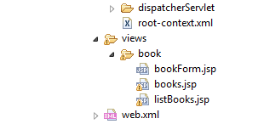
Pom.xml:
<?xml version="1.0" encoding="UTF-8"?>
<project xmlns="http://maven.apache.org/POM/4.0.0" xmlns:xsi="http://www.w3.org/2001/XMLSchema-instance"
xsi:schemaLocation="http://maven.apache.org/POM/4.0.0 http://maven.apache.org/maven-v4_0_0.xsd">
<modelVersion>4.0.0</modelVersion>
<groupId>np.com.mshrestha</groupId>
<artifactId>SpringJquery</artifactId>
<name>SpringJquery</name>
<packaging>war</packaging>
<version>1.0.0-BUILD-SNAPSHOT</version>
<properties>
<java-version>1.7</java-version>
<spring-version>4.0.3.RELEASE</spring-version>
<hibernate-version>4.2.7.Final</hibernate-version>
<mysql-version>5.1.27</mysql-version>
<apache-connection-pooling-version>1.4</apache-connection-pooling-version>
</properties>
<dependencies>
<!-- Spring -->
<dependency>
<groupId>org.springframework</groupId>
<artifactId>spring-context</artifactId>
<version>${spring-version}</version>
</dependency>
<dependency>
<groupId>org.springframework</groupId>
<artifactId>spring-webmvc</artifactId>
<version>${spring-version}</version>
</dependency>
<dependency>
<groupId>org.springframework</groupId>
<artifactId>spring-orm</artifactId>
<version>${spring-version}</version>
</dependency>

<!-- Hibernate -->
<dependency>
<groupId>org.hibernate</groupId>
<artifactId>hibernate-core</artifactId>
<version>${hibernate-version}</version>
</dependency>

<dependency>
<groupId>org.hibernate</groupId>
<artifactId>hibernate-entitymanager</artifactId>
<version>${hibernate-version}</version>
</dependency>

<dependency>
<groupId>commons-dbcp</groupId>
<artifactId>commons-dbcp</artifactId>
<version>${apache-connection-pooling-version}</version>
</dependency>
<dependency>
<groupId>commons-pool</groupId>
<artifactId>commons-pool</artifactId>
<version>${apache-connection-pooling-version}</version>
</dependency>

<!-- MySQL -->
<dependency>
<groupId>mysql</groupId>
<artifactId>mysql-connector-java</artifactId>
<version>${mysql-version}</version>
</dependency>

<!-- Servlet -->
<dependency>
<groupId>javax.servlet</groupId>
<artifactId>servlet-api</artifactId>
<version>2.5</version>
<scope>provided</scope>
</dependency>
<dependency>
<groupId>javax.servlet.jsp</groupId>
<artifactId>jsp-api</artifactId>
<version>2.1</version>
<scope>provided</scope>
</dependency>
<dependency>
<groupId>javax.servlet</groupId>
<artifactId>jstl</artifactId>
<version>1.2</version>
</dependency>

</dependencies>
<build>
<finalName>SpringJquery</finalName>
<plugins>
<plugin>
<groupId>org.apache.maven.plugins</groupId>
<artifactId>maven-compiler-plugin</artifactId>
<configuration>
<source>1.5</source>
<target>1.5</target>
</configuration>
</plugin>
</plugins>
</build>
<repositories>
<repository>
<id>java.net</id>
<url>http://download.java.net/maven/2/</url>
</repository>
</repositories>
</project>
Web.xml:
<?xml version="1.0" encoding="UTF-8"?>
<web-app xmlns:xsi="http://www.w3.org/2001/XMLSchema-instance"
xmlns="http://java.sun.com/xml/ns/javaee"
xsi:schemaLocation="http://java.sun.com/xml/ns/javaee http://java.sun.com/xml/ns/javaee/web-app_2_5.xsd"
version="2.5">

<!-- The definition of the Root Spring Container shared by all Servlets
and Filters -->
<context-param>
<param-name>contextConfigLocation</param-name>
<param-value>/WEB-INF/spring/root-context.xml</param-value>
</context-param>

<!-- Creates the Spring Container shared by all Servlets and Filters -->
<listener>
<listener-class>org.springframework.web.context.ContextLoaderListener</listener-class>
</listener>

<!-- Processes application requests -->
<servlet>
<servlet-name>dispatcherServlet</servlet-name>
<servlet-class>org.springframework.web.servlet.DispatcherServlet</servlet-class>
<init-param>
<param-name>contextConfigLocation</param-name>
<param-value>
/WEB-INF/spring/dispatcherServlet/servlet-context.xml
</param-value>
</init-param>
<load-on-startup>1</load-on-startup>
</servlet>

<servlet-mapping>
<servlet-name>dispatcherServlet</servlet-name>
<url-pattern>/</url-pattern>
</servlet-mapping>

</web-app>

database.properties:
jdbc.driverClassName=com.mysql.jdbc.Driver
jdbc.url=jdbc:mysql://localhost:3306/hibernate
jdbc.username=root
jdbc.password=

hibernate.dialect=org.hibernate.dialect.MySQLDialect

servlet-context.xml:
<?xml version="1.0" encoding="UTF-8"?>
<beans:beans xmlns="http://www.springframework.org/schema/mvc"
xmlns:xsi="http://www.w3.org/2001/XMLSchema-instance" xmlns:beans="http://www.springframework.org/schema/beans"
xmlns:context="http://www.springframework.org/schema/context"
xmlns:mvc="http://www.springframework.org/schema/mvc"
xsi:schemaLocation="http://www.springframework.org/schema/beans http://www.springframework.org/schema/beans/spring-beans.xsd
http://www.springframework.org/schema/context http://www.springframework.org/schema/context/spring-context.xsd
http://www.springframework.org/schema/mvc http://www.springframework.org/schema/mvc/spring-mvc.xsd"
default-lazy-init="true">

<!-- DispatcherServlet Context: defines this servlet's request-processing
infrastructure -->

<!-- Enables the Spring MVC @Controller programming model -->
<annotation-driven />
<context:component-scan base-package="np.com.mshrestha.bookstore.controller" />

<!-- Handles HTTP GET requests for /web-resources/** by efficiently serving
up static resources in the ${webappRoot}/resources/ directory -->
<resources mapping="/web-resources/**" location="/resources/" />

<!-- Resolves views selected for rendering by @Controllers to .jsp resources
in the /WEB-INF/views directory -->
<beans:bean
class="org.springframework.web.servlet.view.InternalResourceViewResolver">
<beans:property name="prefix" value="/WEB-INF/views/" />
<beans:property name="suffix" value=".jsp" />
</beans:bean>
</beans:beans>
root-context.xml:
<?xml version="1.0" encoding="UTF-8"?>
<beans xmlns="http://www.springframework.org/schema/beans"
xmlns:xsi="http://www.w3.org/2001/XMLSchema-instance" xmlns:p="http://www.springframework.org/schema/p"
xmlns:tx="http://www.springframework.org/schema/tx" xmlns:context="http://www.springframework.org/schema/context"
xsi:schemaLocation="http://www.springframework.org/schema/beans
http://www.springframework.org/schema/beans/spring-beans.xsd
http://www.springframework.org/schema/context
http://www.springframework.org/schema/context/spring-context.xsd
http://www.springframework.org/schema/tx
http://www.springframework.org/schema/tx/spring-tx.xsd">

<!-- Root Context: defines shared resources visible to all other web components -->

<context:component-scan base-package="np.com.mshrestha.bookstore" />

<bean id="propertyConfigurer"
class="org.springframework.beans.factory.config.PropertyPlaceholderConfigurer">
<!-- <property name="ignoreUnresolvablePlaceholders" value="true" /> -->
<property name="locations">
<list>
<value>classpath:database.properties</value>
</list>
</property>
</bean>

<bean id="dataSource" class="org.apache.commons.dbcp.BasicDataSource"
destroy-method="close" p:driverClassName="${jdbc.driverClassName}"
p:url="${jdbc.url}" p:username="${jdbc.username}" p:password="${jdbc.password}" />

<bean id="sessionFactory"
class="org.springframework.orm.hibernate4.LocalSessionFactoryBean">
<property name="dataSource" ref="dataSource" />

<property name="packagesToScan">
<list>
<value>np.com.mshrestha.bookstore.model</value>
</list>
</property>
<property name="hibernateProperties">
<props>
<prop key="hibernate.hbm2ddl.auto">update</prop>
<prop key="hibernate.dialect">${hibernate.dialect}</prop>
<prop key="hibernate.show_sql">false</prop>
</props>
</property>
</bean>

<bean id="transactionManager"
class="org.springframework.orm.hibernate4.HibernateTransactionManager">
<property name="sessionFactory" ref="sessionFactory" />
</bean>

<tx:annotation-driven transaction-manager="transactionManager" />

</beans>

Book.java:
package np.com.mshrestha.bookstore.model;

import java.sql.Date;
import javax.persistence.Column;
import javax.persistence.Entity;
import javax.persistence.GeneratedValue;
import javax.persistence.GenerationType;
import javax.persistence.Id;
import javax.persistence.Table;

@Entity
@Table(name = "book")
public class Book {

private Long id;
private String name;
private String code;
private String price;
private String authors;
private String isbn;
private String publisher;
private Date publishedOn;

@Id
@GeneratedValue(strategy = GenerationType.AUTO)
public Long getId() {
return id;
}

@Column(nullable = false)
public String getName() {
return name;
}

@Column(length = 15, nullable = false)
public String getCode() {
return code;
}

@Column(length = 10)
public String getPrice() {
return price;
}

@Column(nullable = false)
public String getAuthors() {
return authors;
}

@Column
public String getIsbn() {
return isbn;
}

@Column
public String getPublisher() {
return publisher;
}

@Column(name = "published_date")
public Date getPublishedOn() {
return publishedOn;
}

public void setId(Long id) {
this.id = id;
}

public void setName(String name) {
this.name = name;
}

public void setCode(String code) {
this.code = code;
}

public void setPrice(String price) {
this.price = price;
}

public void setAuthors(String authors) {
this.authors = authors;
}

public void setIsbn(String isbn) {
this.isbn = isbn;
}

public void setPublisher(String publisher) {
this.publisher = publisher;
}

public void setPublishedOn(Date publishedOn) {
this.publishedOn = publishedOn;
}

}

BookDao.java:
package np.com.mshrestha.bookstore.dao;

import java.util.List;
import np.com.mshrestha.bookstore.model.Book;

public interface BookDao {
public void saveBook(Book book);
public List<Book> listBooks();
public Book getBook(Long id);
public void deleteBook(Long id);
}

BookDaoImpl.java:
package np.com.mshrestha.bookstore.dao.impl;

import java.util.List;
import np.com.mshrestha.bookstore.dao.BookDao;
import np.com.mshrestha.bookstore.model.Book;
import org.hibernate.Session;
import org.hibernate.SessionFactory;
import org.springframework.beans.factory.annotation.Autowired;
import org.springframework.stereotype.Repository;

@Repository
public class BookDaoImpl implements BookDao {

@Autowired
private SessionFactory sessionFactory;

public void saveBook(Book book) {
getSession().merge(book);

}

@SuppressWarnings("unchecked")
public List<Book> listBooks() {

return getSession().createCriteria(Book.class).list();
}

public Book getBook(Long id) {
return (Book) getSession().get(Book.class, id);
}

public void deleteBook(Long id) {

Book book = getBook(id);

if (null != book) {
getSession().delete(book);
}

}

private Session getSession() {
Session sess = getSessionFactory().getCurrentSession();
if (sess == null) {
sess = getSessionFactory().openSession();
}
return sess;
}

private SessionFactory getSessionFactory() {
return sessionFactory;
}
}

BookService.java:
package np.com.mshrestha.bookstore.service;
import java.util.List;
import np.com.mshrestha.bookstore.model.Book;
public interface BookService {
public void saveBook(Book book);
public List<Book> listBooks();
public Book getBook(Long id);
public void deleteBook(Long id);
}
BookServiceImpl.java:
package np.com.mshrestha.bookstore.service.impl;

import java.util.List;
import np.com.mshrestha.bookstore.dao.BookDao;
import np.com.mshrestha.bookstore.model.Book;
import np.com.mshrestha.bookstore.service.BookService;
import org.springframework.beans.factory.annotation.Autowired;
import org.springframework.stereotype.Service;
import org.springframework.transaction.annotation.Transactional;

@Service
public class BookServiceImpl implements BookService {

@Autowired
private BookDao bookDao;

@Transactional
public void saveBook(Book book) {
bookDao.saveBook(book);
}

@Transactional(readOnly = true)
public List<Book> listBooks() {
return bookDao.listBooks();
}

@Transactional(readOnly = true)
public Book getBook(Long id) {
return bookDao.getBook(id);
}

@Transactional
public void deleteBook(Long id) {
bookDao.deleteBook(id);

}
}

BookController.java:
package np.com.mshrestha.bookstore.controller;

import java.util.Map;
import np.com.mshrestha.bookstore.model.Book;
import np.com.mshrestha.bookstore.service.BookService;
import org.springframework.beans.factory.annotation.Autowired;
import org.springframework.stereotype.Controller;
import org.springframework.validation.BindingResult;
import org.springframework.web.bind.annotation.ModelAttribute;
import org.springframework.web.bind.annotation.PathVariable;
import org.springframework.web.bind.annotation.RequestMapping;
import org.springframework.web.bind.annotation.RequestMethod;

@Controller
@RequestMapping("/book")
public class BookController {

@Autowired
private BookService bookService;

@RequestMapping(value = "/listBooks",method = RequestMethod.GET)
public String listBooks(Map<String, Object> map) {
map.put("book", new Book());
map.put("bookList", bookService.listBooks());
return "/book/listBooks";
}

@RequestMapping(value = "/books",method = RequestMethod.GET)
public String listBooksDataTable(Map<String, Object> map) {

map.put("book", new Book());
map.put("bookList", bookService.listBooks());

return "/book/books";
}

@RequestMapping("/get/{bookId}")
public String getBook(@PathVariable Long bookId, Map<String, Object> map) {
Book book = bookService.getBook(bookId);
map.put("book", book);
return "/book/bookForm";
}

@RequestMapping(value = "/save", method = RequestMethod.POST)
public String saveBook(@ModelAttribute("book") Book book,
BindingResult result) {
bookService.saveBook(book);
return "redirect:books";
}

@RequestMapping("/delete/{bookId}")
public String deleteBook(@PathVariable("bookId") Long id) {
bookService.deleteBook(id);
return "redirect:/book/books";
}
}

listBooks.jsp:
<%@ taglib uri="http://java.sun.com/jsp/jstl/core" prefix="c"%>

<html>
<head>
<title>List Of Books</title>

<link rel="stylesheet"
href='<c:url value="/web-resources/lib/bootstrap-3.3.6/css/bootstrap.min.css"/>'>

<link rel="stylesheet"
href='<c:url value="/web-resources/lib/jquery/jquery-ui-1.10.4.custom.css"/>'>

<style type="text/css">
th {
text-align: left
}
</style>

</head>

<body>
<div style="width: 95%; margin: 0 auto;">

<div id="bookDialog" style="display: none;">
<%@ include file="bookForm.jsp"%>
</div>

<h1>List Of Books</h1>

<button class="btn btn-primary" onclick="addBook()">
<span class="glyphicon glyphicon-plus" aria-hidden="true"></span> Add Book
</button>
<br>
<table class="table table-striped table-bordered">
<thead>
<tr>
<th width="4%">S.N</th>
<th width="12%">Name</th>
<th width="12%">Code</th>
<th width="12%">Price</th>
<th width="12%">Authors</th>
<th width="12%">ISBN</th>
<th width="12%">Publisher</th>
<th width="12%">Published On</th>
<th width="12%"></th>
</tr>
</thead>
<tbody>
<c:forEach items="${bookList}" var="book" varStatus="loopCounter">
<tr>
<td><c:out value="${loopCounter.count}" /></td>
<td><c:out value="${book.name}" /></td>
<td><c:out value="${book.code}" /></td>
<td><c:out value="${book.price}" /></td>
<td><c:out value="${book.authors}" /></td>
<td><c:out value="${book.isbn}" /></td>
<td><c:out value="${book.publisher}" /></td>
<td><c:out value="${book.publishedOn}" /></td>

<td><nobr>
<button class="btn btn-primary"
onclick="editBook(${book.id});">

<span class="glyphicon glyphicon-pencil" aria-hidden="true"></span> Edit
</button>

<a class="btn btn-primary"
onclick="return confirm('Are you sure you want to delete this book?');"
href="delete/${book.id}">
<span class="glyphicon glyphicon-trash" aria-hidden="true"></span> Delete
</a>

</nobr></td>
</tr>
</c:forEach>
</tbody>
</table>

</div>

<!-- It is advised to put the <script> tags at the end of the document body so they don't block rendering of the page -->
<script type="text/javascript"
src='<c:url value="/web-resources/lib/jquery/jquery-1.10.2.js"/>'></script>
<script type="text/javascript"
src='<c:url value="/web-resources/lib/jquery/jquery-ui-1.10.4.custom.js"/>'></script>
<script type="text/javascript"
src='<c:url value="/web-resources/lib/jquery/jquery.ui.datepicker.js"/>'></script>
<script type="text/javascript"
src='<c:url value="/web-resources/lib/bootstrap-3.3.6/js/bootstrap.min.js"/>'></script>
<script type="text/javascript"
src='<c:url value="/web-resources/js/js-for-listBooks.js"/>'></script>
</body>
</html>
js-for-listBooks.js:
function addBook() {
$('#bookDialog').dialog("option", "title", 'Add Book');
$('#bookDialog').dialog('open');
}

function editBook(id) {

$.get("get/" + id, function(result) {

$("#bookDialog").html(result);

$('#bookDialog').dialog("option", "title", 'Edit Book');

$("#bookDialog").dialog('open');

initializeDatePicker();
});
}

function initializeDatePicker() {
$(".datepicker").datepicker({
dateFormat : "yy-mm-dd",
changeMonth : true,
changeYear : true,
showButtonPanel : true
});
}

function resetDialog(form) {

form.find("input").val("");
}

$(document).ready(function() {

$('#bookDialog').dialog({

autoOpen : false,
position : 'center',
modal : true,
resizable : false,
width : 440,
buttons : {
"Save" : function() {
$('#bookForm').submit();
},
"Cancel" : function() {
$(this).dialog('close');
}
},
close : function() {

resetDialog($('#bookForm'));

$(this).dialog('close');
}
});

initializeDatePicker();
});

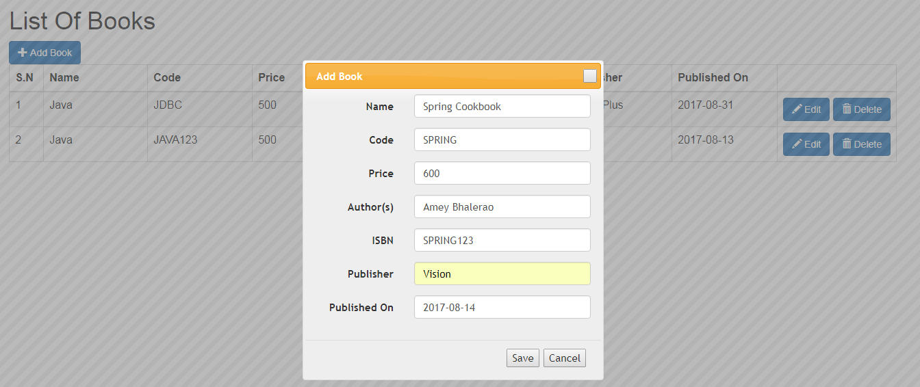
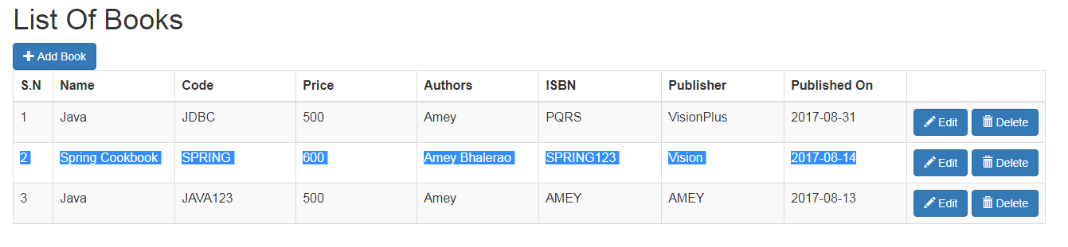
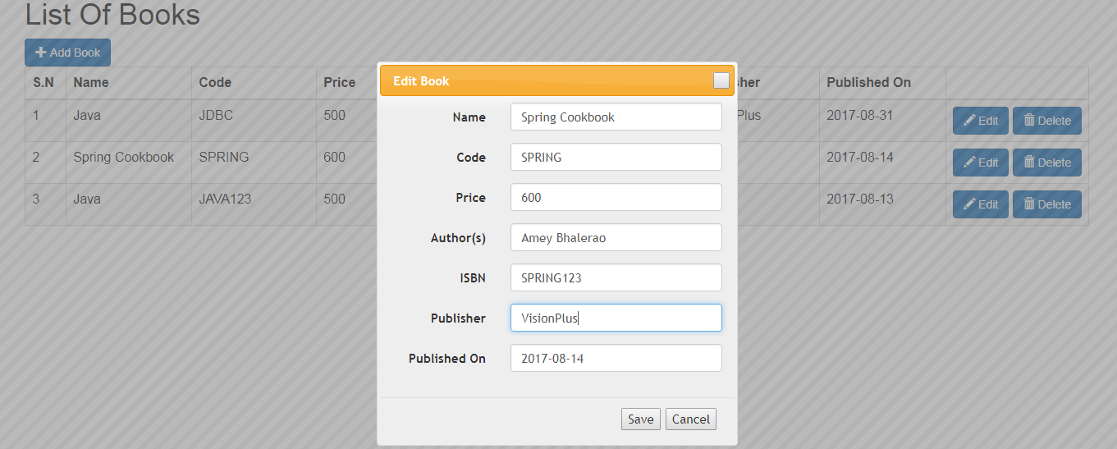
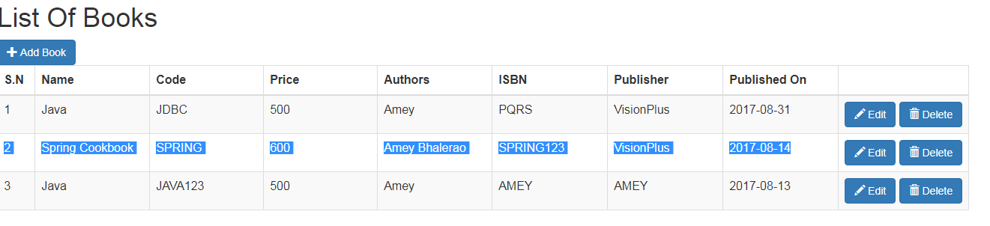
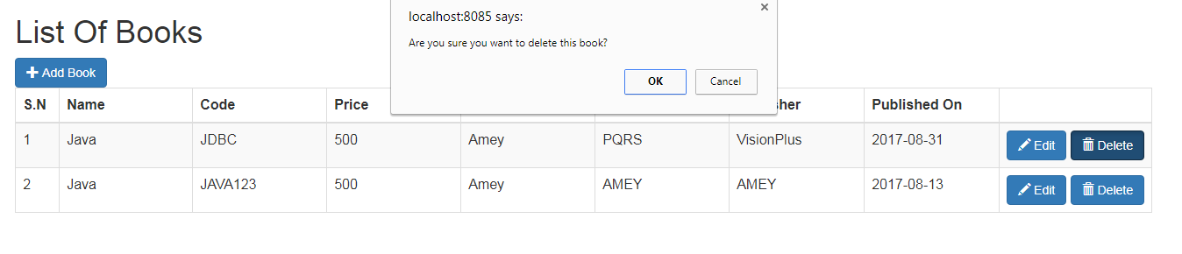

Project Structure:
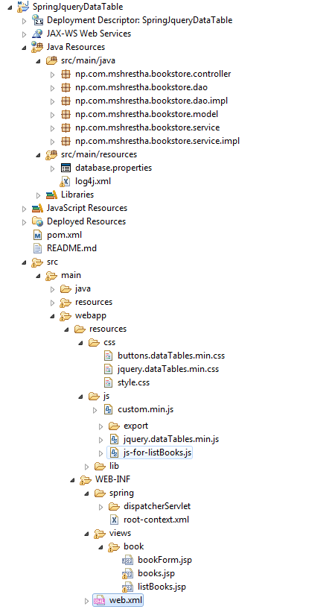
Pom.xml:
<?xml version="1.0" encoding="UTF-8"?>
<project xmlns="http://maven.apache.org/POM/4.0.0" xmlns:xsi="http://www.w3.org/2001/XMLSchema-instance"
xsi:schemaLocation="http://maven.apache.org/POM/4.0.0 http://maven.apache.org/maven-v4_0_0.xsd">
<modelVersion>4.0.0</modelVersion>
<groupId>np.com.mshrestha</groupId>
<artifactId>SpringJquery</artifactId>
<name>SpringJquery</name>
<packaging>war</packaging>
<version>1.0.0-BUILD-SNAPSHOT</version>
<properties>
<java-version>1.7</java-version>
<spring-version>4.0.3.RELEASE</spring-version>
<hibernate-version>4.2.7.Final</hibernate-version>
<mysql-version>5.1.27</mysql-version>
<apache-connection-pooling-version>1.4</apache-connection-pooling-version>
</properties>
<dependencies>
<!-- Spring -->
<dependency>
<groupId>org.springframework</groupId>
<artifactId>spring-context</artifactId>
<version>${spring-version}</version>
</dependency>
<dependency>
<groupId>org.springframework</groupId>
<artifactId>spring-webmvc</artifactId>
<version>${spring-version}</version>
</dependency>
<dependency>
<groupId>org.springframework</groupId>
<artifactId>spring-orm</artifactId>
<version>${spring-version}</version>
</dependency>

<!-- Hibernate -->
<dependency>
<groupId>org.hibernate</groupId>
<artifactId>hibernate-core</artifactId>
<version>${hibernate-version}</version>
</dependency>

<dependency>
<groupId>org.hibernate</groupId>
<artifactId>hibernate-entitymanager</artifactId>
<version>${hibernate-version}</version>
</dependency>

<dependency>
<groupId>commons-dbcp</groupId>
<artifactId>commons-dbcp</artifactId>
<version>${apache-connection-pooling-version}</version>
</dependency>
<dependency>
<groupId>commons-pool</groupId>
<artifactId>commons-pool</artifactId>
<version>${apache-connection-pooling-version}</version>
</dependency>

<!-- MySQL -->
<dependency>
<groupId>mysql</groupId>
<artifactId>mysql-connector-java</artifactId>
<version>${mysql-version}</version>
</dependency>

<!-- Servlet -->
<dependency>
<groupId>javax.servlet</groupId>
<artifactId>servlet-api</artifactId>
<version>2.5</version>
<scope>provided</scope>
</dependency>
<dependency>
<groupId>javax.servlet.jsp</groupId>
<artifactId>jsp-api</artifactId>
<version>2.1</version>
<scope>provided</scope>
</dependency>
<dependency>
<groupId>javax.servlet</groupId>
<artifactId>jstl</artifactId>
<version>1.2</version>
</dependency>

</dependencies>
<build>
<finalName>SpringJquery</finalName>
<plugins>
<plugin>
<groupId>org.apache.maven.plugins</groupId>
<artifactId>maven-compiler-plugin</artifactId>
<configuration>
<source>1.5</source>
<target>1.5</target>
</configuration>
</plugin>
</plugins>
</build>
<repositories>
<repository>
<id>java.net</id>
<url>http://download.java.net/maven/2/</url>
</repository>
</repositories>
</project>
Web.xml:
<?xml version="1.0" encoding="UTF-8"?>
<web-app xmlns:xsi="http://www.w3.org/2001/XMLSchema-instance"
xmlns="http://java.sun.com/xml/ns/javaee"
xsi:schemaLocation="http://java.sun.com/xml/ns/javaee http://java.sun.com/xml/ns/javaee/web-app_2_5.xsd"
version="2.5">

<!-- The definition of the Root Spring Container shared by all Servlets
and Filters -->
<context-param>
<param-name>contextConfigLocation</param-name>
<param-value>/WEB-INF/spring/root-context.xml</param-value>
</context-param>

<!-- Creates the Spring Container shared by all Servlets and Filters -->
<listener>
<listener-class>org.springframework.web.context.ContextLoaderListener</listener-class>
</listener>

<!-- Processes application requests -->
<servlet>
<servlet-name>dispatcherServlet</servlet-name>
<servlet-class>org.springframework.web.servlet.DispatcherServlet</servlet-class>
<init-param>
<param-name>contextConfigLocation</param-name>
<param-value>
/WEB-INF/spring/dispatcherServlet/servlet-context.xml
</param-value>
</init-param>
<load-on-startup>1</load-on-startup>
</servlet>

<servlet-mapping>
<servlet-name>dispatcherServlet</servlet-name>
<url-pattern>/</url-pattern>
</servlet-mapping>

</web-app>

database.properties:
jdbc.driverClassName=com.mysql.jdbc.Driver
jdbc.url=jdbc:mysql://localhost:3306/hibernate
jdbc.username=root
jdbc.password=

hibernate.dialect=org.hibernate.dialect.MySQLDialect

servlet-context.xml:
<?xml version="1.0" encoding="UTF-8"?>
<beans:beans xmlns="http://www.springframework.org/schema/mvc"
xmlns:xsi="http://www.w3.org/2001/XMLSchema-instance" xmlns:beans="http://www.springframework.org/schema/beans"
xmlns:context="http://www.springframework.org/schema/context"
xmlns:mvc="http://www.springframework.org/schema/mvc"
xsi:schemaLocation="http://www.springframework.org/schema/beans http://www.springframework.org/schema/beans/spring-beans.xsd
http://www.springframework.org/schema/context http://www.springframework.org/schema/context/spring-context.xsd
http://www.springframework.org/schema/mvc http://www.springframework.org/schema/mvc/spring-mvc.xsd"
default-lazy-init="true">

<!-- DispatcherServlet Context: defines this servlet's request-processing
infrastructure -->

<!-- Enables the Spring MVC @Controller programming model -->
<annotation-driven />
<context:component-scan base-package="np.com.mshrestha.bookstore.controller" />

<!-- Handles HTTP GET requests for /web-resources/** by efficiently serving
up static resources in the ${webappRoot}/resources/ directory -->
<resources mapping="/web-resources/**" location="/resources/" />

<!-- Resolves views selected for rendering by @Controllers to .jsp resources
in the /WEB-INF/views directory -->
<beans:bean
class="org.springframework.web.servlet.view.InternalResourceViewResolver">
<beans:property name="prefix" value="/WEB-INF/views/" />
<beans:property name="suffix" value=".jsp" />
</beans:bean>
</beans:beans>
root-context.xml:
<?xml version="1.0" encoding="UTF-8"?>
<beans xmlns="http://www.springframework.org/schema/beans"
xmlns:xsi="http://www.w3.org/2001/XMLSchema-instance" xmlns:p="http://www.springframework.org/schema/p"
xmlns:tx="http://www.springframework.org/schema/tx" xmlns:context="http://www.springframework.org/schema/context"
xsi:schemaLocation="http://www.springframework.org/schema/beans
http://www.springframework.org/schema/beans/spring-beans.xsd
http://www.springframework.org/schema/context
http://www.springframework.org/schema/context/spring-context.xsd
http://www.springframework.org/schema/tx
http://www.springframework.org/schema/tx/spring-tx.xsd">

<!-- Root Context: defines shared resources visible to all other web components -->

<context:component-scan base-package="np.com.mshrestha.bookstore" />

<bean id="propertyConfigurer"
class="org.springframework.beans.factory.config.PropertyPlaceholderConfigurer">
<!-- <property name="ignoreUnresolvablePlaceholders" value="true" /> -->
<property name="locations">
<list>
<value>classpath:database.properties</value>
</list>
</property>
</bean>

<bean id="dataSource" class="org.apache.commons.dbcp.BasicDataSource"
destroy-method="close" p:driverClassName="${jdbc.driverClassName}"
p:url="${jdbc.url}" p:username="${jdbc.username}" p:password="${jdbc.password}" />

<bean id="sessionFactory"
class="org.springframework.orm.hibernate4.LocalSessionFactoryBean">
<property name="dataSource" ref="dataSource" />

<property name="packagesToScan">
<list>
<value>np.com.mshrestha.bookstore.model</value>
</list>
</property>
<property name="hibernateProperties">
<props>
<prop key="hibernate.hbm2ddl.auto">update</prop>
<prop key="hibernate.dialect">${hibernate.dialect}</prop>
<prop key="hibernate.show_sql">false</prop>
</props>
</property>
</bean>

<bean id="transactionManager"
class="org.springframework.orm.hibernate4.HibernateTransactionManager">
<property name="sessionFactory" ref="sessionFactory" />
</bean>

<tx:annotation-driven transaction-manager="transactionManager" />

</beans>

Book.java:
package np.com.mshrestha.bookstore.model;

import java.sql.Date;
import javax.persistence.Column;
import javax.persistence.Entity;
import javax.persistence.GeneratedValue;
import javax.persistence.GenerationType;
import javax.persistence.Id;
import javax.persistence.Table;

@Entity
@Table(name = "book")
public class Book {

private Long id;
private String name;
private String code;
private String price;
private String authors;
private String isbn;
private String publisher;
private Date publishedOn;

@Id
@GeneratedValue(strategy = GenerationType.AUTO)
public Long getId() {
return id;
}

@Column(nullable = false)
public String getName() {
return name;
}

@Column(length = 15, nullable = false)
public String getCode() {
return code;
}

@Column(length = 10)
public String getPrice() {
return price;
}

@Column(nullable = false)
public String getAuthors() {
return authors;
}

@Column
public String getIsbn() {
return isbn;
}

@Column
public String getPublisher() {
return publisher;
}

@Column(name = "published_date")
public Date getPublishedOn() {
return publishedOn;
}

public void setId(Long id) {
this.id = id;
}

public void setName(String name) {
this.name = name;
}

public void setCode(String code) {
this.code = code;
}

public void setPrice(String price) {
this.price = price;
}

public void setAuthors(String authors) {
this.authors = authors;
}

public void setIsbn(String isbn) {
this.isbn = isbn;
}

public void setPublisher(String publisher) {
this.publisher = publisher;
}

public void setPublishedOn(Date publishedOn) {
this.publishedOn = publishedOn;
}

}

BookDao.java:
package np.com.mshrestha.bookstore.dao;

import java.util.List;
import np.com.mshrestha.bookstore.model.Book;

public interface BookDao {
public void saveBook(Book book);
public List<Book> listBooks();
public Book getBook(Long id);
public void deleteBook(Long id);
}

BookDaoImpl.java:
package np.com.mshrestha.bookstore.dao.impl;

import java.util.List;
import np.com.mshrestha.bookstore.dao.BookDao;
import np.com.mshrestha.bookstore.model.Book;
import org.hibernate.Session;
import org.hibernate.SessionFactory;
import org.springframework.beans.factory.annotation.Autowired;
import org.springframework.stereotype.Repository;

@Repository
public class BookDaoImpl implements BookDao {

@Autowired
private SessionFactory sessionFactory;

public void saveBook(Book book) {
getSession().merge(book);

}

@SuppressWarnings("unchecked")
public List<Book> listBooks() {

return getSession().createCriteria(Book.class).list();
}

public Book getBook(Long id) {
return (Book) getSession().get(Book.class, id);
}

public void deleteBook(Long id) {

Book book = getBook(id);

if (null != book) {
getSession().delete(book);
}

}

private Session getSession() {
Session sess = getSessionFactory().getCurrentSession();
if (sess == null) {
sess = getSessionFactory().openSession();
}
return sess;
}

private SessionFactory getSessionFactory() {
return sessionFactory;
}
}

BookService.java:
package np.com.mshrestha.bookstore.service;
import java.util.List;
import np.com.mshrestha.bookstore.model.Book;
public interface BookService {
public void saveBook(Book book);
public List<Book> listBooks();
public Book getBook(Long id);
public void deleteBook(Long id);
}
BookServiceImpl.java:
package np.com.mshrestha.bookstore.service.impl;

import java.util.List;
import np.com.mshrestha.bookstore.dao.BookDao;
import np.com.mshrestha.bookstore.model.Book;
import np.com.mshrestha.bookstore.service.BookService;
import org.springframework.beans.factory.annotation.Autowired;
import org.springframework.stereotype.Service;
import org.springframework.transaction.annotation.Transactional;

@Service
public class BookServiceImpl implements BookService {

@Autowired
private BookDao bookDao;

@Transactional
public void saveBook(Book book) {
bookDao.saveBook(book);
}

@Transactional(readOnly = true)
public List<Book> listBooks() {
return bookDao.listBooks();
}

@Transactional(readOnly = true)
public Book getBook(Long id) {
return bookDao.getBook(id);
}

@Transactional
public void deleteBook(Long id) {
bookDao.deleteBook(id);

}
}

BookController.java:
package np.com.mshrestha.bookstore.controller;

import java.util.Map;
import np.com.mshrestha.bookstore.model.Book;
import np.com.mshrestha.bookstore.service.BookService;
import org.springframework.beans.factory.annotation.Autowired;
import org.springframework.stereotype.Controller;
import org.springframework.validation.BindingResult;
import org.springframework.web.bind.annotation.ModelAttribute;
import org.springframework.web.bind.annotation.PathVariable;
import org.springframework.web.bind.annotation.RequestMapping;
import org.springframework.web.bind.annotation.RequestMethod;

@Controller
@RequestMapping("/book")
public class BookController {

@Autowired
private BookService bookService;

@RequestMapping(value = "/listBooks",method = RequestMethod.GET)
public String listBooks(Map<String, Object> map) {
map.put("book", new Book());
map.put("bookList", bookService.listBooks());
return "/book/listBooks";
}

@RequestMapping(value = "/books",method = RequestMethod.GET)
public String listBooksDataTable(Map<String, Object> map) {

map.put("book", new Book());
map.put("bookList", bookService.listBooks());

return "/book/books";
}

@RequestMapping("/get/{bookId}")
public String getBook(@PathVariable Long bookId, Map<String, Object> map) {
Book book = bookService.getBook(bookId);
map.put("book", book);
return "/book/bookForm";
}

@RequestMapping(value = "/save", method = RequestMethod.POST)
public String saveBook(@ModelAttribute("book") Book book,
BindingResult result) {
bookService.saveBook(book);
return "redirect:books";
}

@RequestMapping("/delete/{bookId}")
public String deleteBook(@PathVariable("bookId") Long id) {
bookService.deleteBook(id);
return "redirect:/book/books";
}
}

books.jsp:
<%@ taglib uri="http://java.sun.com/jsp/jstl/core" prefix="c"%>

<html>
<head>
<title>List Of Books</title>
<link rel="stylesheet" href='<c:url value="/web-resources/lib/bootstrap-3.3.6/css/bootstrap.min.css"/>'>
<link rel="stylesheet" href='<c:url value="/web-resources/lib/jquery/jquery-ui-1.10.4.custom.css"/>'>
<link href='<c:url value="/web-resources/css/jquery.dataTables.min.css"/>' rel="stylesheet" type="text/css">
<link href='<c:url value="/web-resources/css/buttons.dataTables.min.css"/>' rel="stylesheet" type="text/css">

<style type="text/css">
th {
text-align: left
}
</style>
</head>

<body>
<div style="width: 95%; margin: 0 auto;">

<div id="bookDialog" style="display: none;">
<%@ include file="bookForm.jsp"%>
</div>

<h1>List Of Books</h1>

<button class="btn btn-primary" onclick="addBook()">
<span class="glyphicon glyphicon-plus" aria-hidden="true"></span> Add Book
</button><br>
<br>
<table id='example23' class='display nowrap' cellspacing='0' width='100%'>
<thead>
<tr>
<th width="4%">S.N</th>
<th width="12%">Name</th>
<th width="12%">Code</th>
<th width="12%">Price</th>
<th width="12%">Authors</th>
<th width="12%">ISBN</th>
<th width="12%">Publisher</th>
<th width="12%">Published On</th>
<th width="12%"></th>
</tr>
</thead>
<tbody>
<c:forEach items="${bookList}" var="book" varStatus="loopCounter">
<tr>
<td><c:out value="${loopCounter.count}" /></td>
<td><c:out value="${book.name}" /></td>
<td><c:out value="${book.code}" /></td>
<td><c:out value="${book.price}" /></td>
<td><c:out value="${book.authors}" /></td>
<td><c:out value="${book.isbn}" /></td>
<td><c:out value="${book.publisher}" /></td>
<td><c:out value="${book.publishedOn}" /></td>

<td><nobr>
<button class="btn btn-primary"
onclick="editBook(${book.id});">

<span class="glyphicon glyphicon-pencil" aria-hidden="true"></span> Edit
</button>

<a class="btn btn-primary"
onclick="return confirm('Are you sure you want to delete this book?');"
href="delete/${book.id}">
<span class="glyphicon glyphicon-trash" aria-hidden="true"></span> Delete
</a>

</nobr></td>
</tr>
</c:forEach>
</tbody>
</table>

</div>

<!-- It is advised to put the <script> tags at the end of the document body so they don't block rendering of the page -->
<script type="text/javascript" src='<c:url value="/web-resources/lib/jquery/jquery-1.10.2.js"/>'></script>
<script type="text/javascript" src='<c:url value="/web-resources/lib/jquery/jquery-ui-1.10.4.custom.js"/>'></script>
<script type="text/javascript" src='<c:url value="/web-resources/lib/jquery/jquery.ui.datepicker.js"/>'></script>
<script type="text/javascript" src='<c:url value="/web-resources/lib/bootstrap-3.3.6/js/bootstrap.min.js"/>'></script>
<script type="text/javascript" src='<c:url value="/web-resources/js/js-for-listBooks.js"/>'></script>
<script type="text/javascript" src='<c:url value="/web-resources/js/custom.min.js"/>'></script>
<script type="text/javascript" src='<c:url value="/web-resources/js/jquery.dataTables.min.js"/>'></script>
<!-- start - This is for export functionality only -->
<script type="text/javascript" src='<c:url value="/web-resources/js/export/dataTables.buttons.min.js"/>'></script>
<script type="text/javascript" src='<c:url value="/web-resources/js/export/buttons.flash.min.js"/>'></script>
<script type="text/javascript" src='<c:url value="/web-resources/js/export/jszip.min.js"/>'></script>
<script type="text/javascript" src='<c:url value="/web-resources/js/export/pdfmake.min.js"/>'></script>
<script type="text/javascript" src='<c:url value="/web-resources/js/export/vfs_fonts.js"/>'></script>
<script type="text/javascript" src='<c:url value="/web-resources/js/export/buttons.html5.min.js"/>'></script>
<script type="text/javascript" src='<c:url value="/web-resources/js/export/buttons.print.min.js"/>'></script>
<!-- end - This is for export functionality only -->
<script>

$('#example23').DataTable( {
dom: 'Bfrtip',
buttons: [
'copy', 'csv', 'excel', 'pdf', 'print'
]
});
</script>
</body>
</html>

js-for-listBooks.js:
function addBook() {
$('#bookDialog').dialog("option", "title", 'Add Book');
$('#bookDialog').dialog('open');
}

function editBook(id) {

$.get("get/" + id, function(result) {

$("#bookDialog").html(result);

$('#bookDialog').dialog("option", "title", 'Edit Book');

$("#bookDialog").dialog('open');

initializeDatePicker();
});
}

function initializeDatePicker() {
$(".datepicker").datepicker({
dateFormat : "yy-mm-dd",
changeMonth : true,
changeYear : true,
showButtonPanel : true
});
}

function resetDialog(form) {

form.find("input").val("");
}

$(document).ready(function() {

$('#bookDialog').dialog({

autoOpen : false,
position : 'center',
modal : true,
resizable : false,
width : 440,
buttons : {
"Save" : function() {
$('#bookForm').submit();
},
"Cancel" : function() {
$(this).dialog('close');
}
},
close : function() {

resetDialog($('#bookForm'));

$(this).dialog('close');
}
});

initializeDatePicker();
});

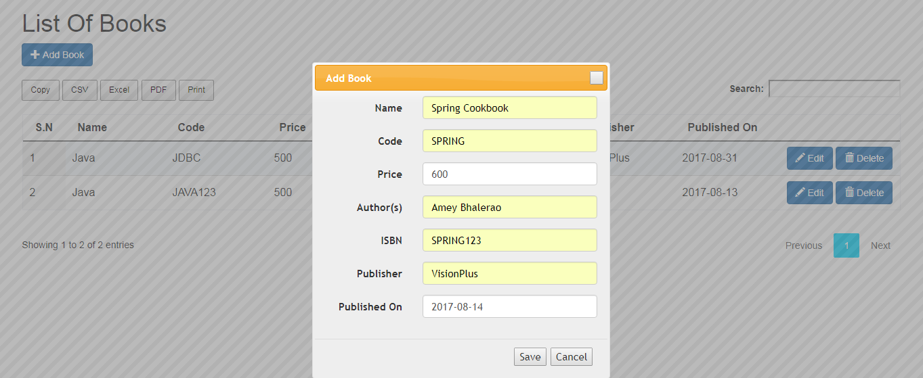
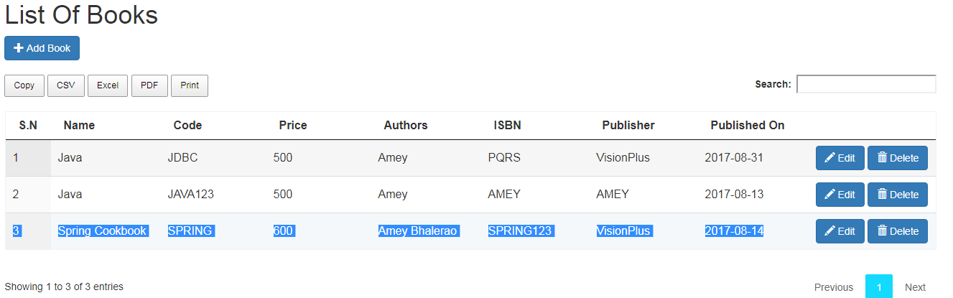
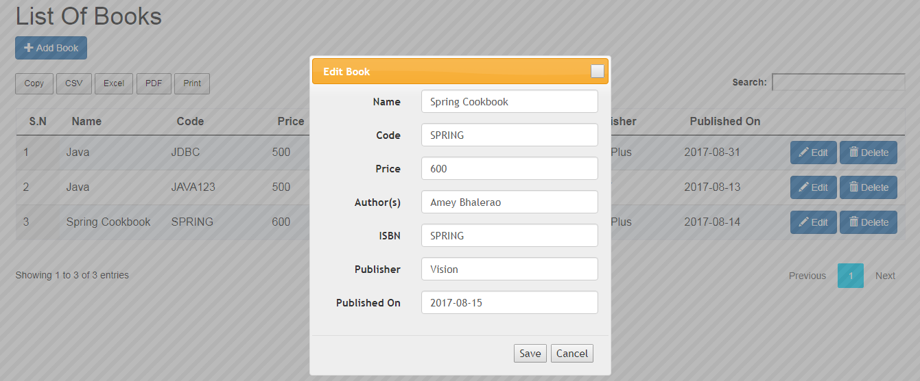
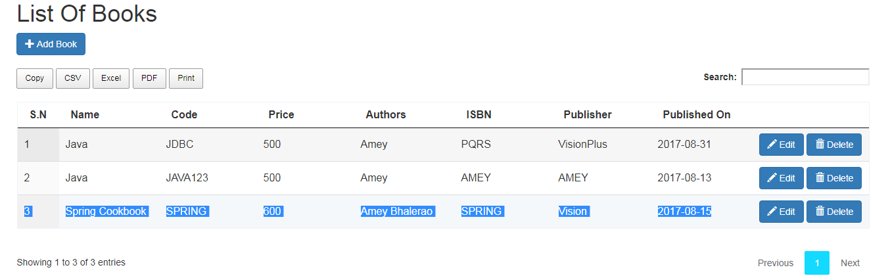
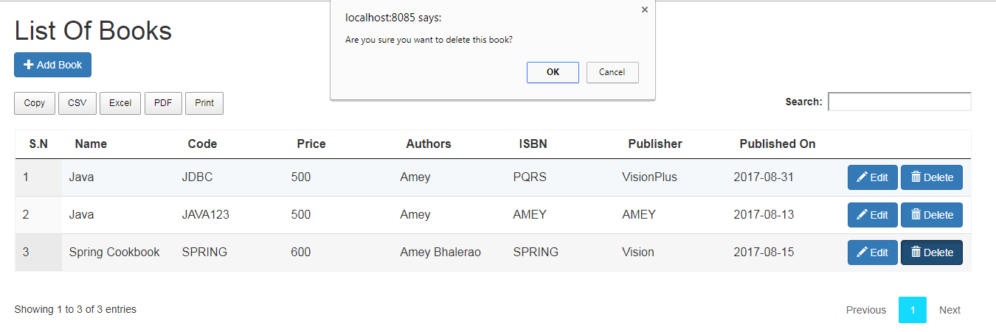
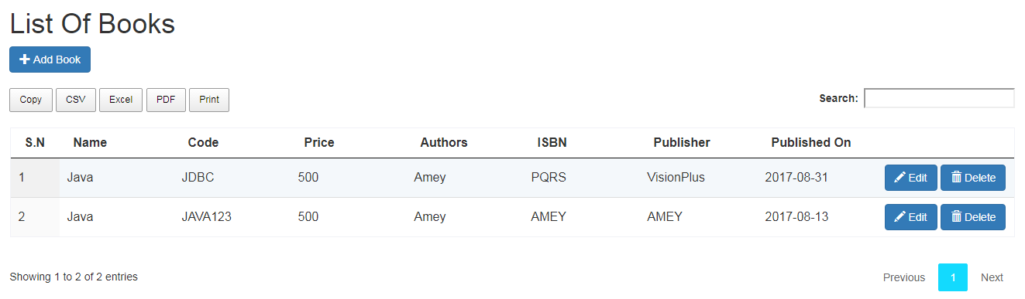

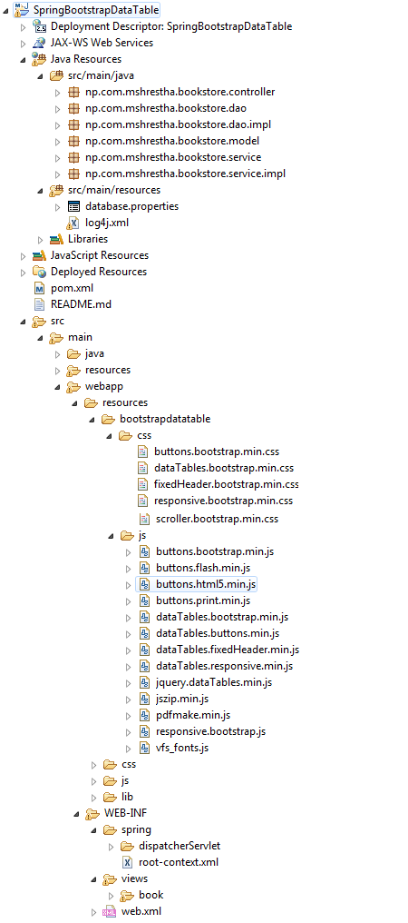

Pom.xml:
<?xml version="1.0" encoding="UTF-8"?>
<project xmlns="http://maven.apache.org/POM/4.0.0" xmlns:xsi="http://www.w3.org/2001/XMLSchema-instance"
xsi:schemaLocation="http://maven.apache.org/POM/4.0.0 http://maven.apache.org/maven-v4_0_0.xsd">
<modelVersion>4.0.0</modelVersion>
<groupId>np.com.mshrestha</groupId>
<artifactId>SpringJquery</artifactId>
<name>SpringJquery</name>
<packaging>war</packaging>
<version>1.0.0-BUILD-SNAPSHOT</version>
<properties>
<java-version>1.7</java-version>
<spring-version>4.0.3.RELEASE</spring-version>
<hibernate-version>4.2.7.Final</hibernate-version>
<mysql-version>5.1.27</mysql-version>
<apache-connection-pooling-version>1.4</apache-connection-pooling-version>
</properties>
<dependencies>
<!-- Spring -->
<dependency>
<groupId>org.springframework</groupId>
<artifactId>spring-context</artifactId>
<version>${spring-version}</version>
</dependency>
<dependency>
<groupId>org.springframework</groupId>
<artifactId>spring-webmvc</artifactId>
<version>${spring-version}</version>
</dependency>
<dependency>
<groupId>org.springframework</groupId>
<artifactId>spring-orm</artifactId>
<version>${spring-version}</version>
</dependency>

<!-- Hibernate -->
<dependency>
<groupId>org.hibernate</groupId>
<artifactId>hibernate-core</artifactId>
<version>${hibernate-version}</version>
</dependency>

<dependency>
<groupId>org.hibernate</groupId>
<artifactId>hibernate-entitymanager</artifactId>
<version>${hibernate-version}</version>
</dependency>

<dependency>
<groupId>commons-dbcp</groupId>
<artifactId>commons-dbcp</artifactId>
<version>${apache-connection-pooling-version}</version>
</dependency>
<dependency>
<groupId>commons-pool</groupId>
<artifactId>commons-pool</artifactId>
<version>${apache-connection-pooling-version}</version>
</dependency>

<!-- MySQL -->
<dependency>
<groupId>mysql</groupId>
<artifactId>mysql-connector-java</artifactId>
<version>${mysql-version}</version>
</dependency>

<!-- Servlet -->
<dependency>
<groupId>javax.servlet</groupId>
<artifactId>servlet-api</artifactId>
<version>2.5</version>
<scope>provided</scope>
</dependency>
<dependency>
<groupId>javax.servlet.jsp</groupId>
<artifactId>jsp-api</artifactId>
<version>2.1</version>
<scope>provided</scope>
</dependency>
<dependency>
<groupId>javax.servlet</groupId>
<artifactId>jstl</artifactId>
<version>1.2</version>
</dependency>

</dependencies>
<build>
<finalName>SpringJquery</finalName>
<plugins>
<plugin>
<groupId>org.apache.maven.plugins</groupId>
<artifactId>maven-compiler-plugin</artifactId>
<configuration>
<source>1.5</source>
<target>1.5</target>
</configuration>
</plugin>
</plugins>
</build>
<repositories>
<repository>
<id>java.net</id>
<url>http://download.java.net/maven/2/</url>
</repository>
</repositories>
</project>
Web.xml:
<?xml version="1.0" encoding="UTF-8"?>
<web-app xmlns:xsi="http://www.w3.org/2001/XMLSchema-instance"
xmlns="http://java.sun.com/xml/ns/javaee"
xsi:schemaLocation="http://java.sun.com/xml/ns/javaee http://java.sun.com/xml/ns/javaee/web-app_2_5.xsd"
version="2.5">

<!-- The definition of the Root Spring Container shared by all Servlets
and Filters -->
<context-param>
<param-name>contextConfigLocation</param-name>
<param-value>/WEB-INF/spring/root-context.xml</param-value>
</context-param>

<!-- Creates the Spring Container shared by all Servlets and Filters -->
<listener>
<listener-class>org.springframework.web.context.ContextLoaderListener</listener-class>
</listener>

<!-- Processes application requests -->
<servlet>
<servlet-name>dispatcherServlet</servlet-name>
<servlet-class>org.springframework.web.servlet.DispatcherServlet</servlet-class>
<init-param>
<param-name>contextConfigLocation</param-name>
<param-value>
/WEB-INF/spring/dispatcherServlet/servlet-context.xml
</param-value>
</init-param>
<load-on-startup>1</load-on-startup>
</servlet>

<servlet-mapping>
<servlet-name>dispatcherServlet</servlet-name>
<url-pattern>/</url-pattern>
</servlet-mapping>

</web-app>

database.properties:
jdbc.driverClassName=com.mysql.jdbc.Driver
jdbc.url=jdbc:mysql://localhost:3306/hibernate
jdbc.username=root
jdbc.password=

hibernate.dialect=org.hibernate.dialect.MySQLDialect

servlet-context.xml:
<?xml version="1.0" encoding="UTF-8"?>
<beans:beans xmlns="http://www.springframework.org/schema/mvc"
xmlns:xsi="http://www.w3.org/2001/XMLSchema-instance" xmlns:beans="http://www.springframework.org/schema/beans"
xmlns:context="http://www.springframework.org/schema/context"
xmlns:mvc="http://www.springframework.org/schema/mvc"
xsi:schemaLocation="http://www.springframework.org/schema/beans http://www.springframework.org/schema/beans/spring-beans.xsd
http://www.springframework.org/schema/context http://www.springframework.org/schema/context/spring-context.xsd
http://www.springframework.org/schema/mvc http://www.springframework.org/schema/mvc/spring-mvc.xsd"
default-lazy-init="true">

<!-- DispatcherServlet Context: defines this servlet's request-processing
infrastructure -->

<!-- Enables the Spring MVC @Controller programming model -->
<annotation-driven />
<context:component-scan base-package="np.com.mshrestha.bookstore.controller" />

<!-- Handles HTTP GET requests for /web-resources/** by efficiently serving
up static resources in the ${webappRoot}/resources/ directory -->
<resources mapping="/web-resources/**" location="/resources/" />

<!-- Resolves views selected for rendering by @Controllers to .jsp resources
in the /WEB-INF/views directory -->
<beans:bean
class="org.springframework.web.servlet.view.InternalResourceViewResolver">
<beans:property name="prefix" value="/WEB-INF/views/" />
<beans:property name="suffix" value=".jsp" />
</beans:bean>
</beans:beans>
root-context.xml:
<?xml version="1.0" encoding="UTF-8"?>
<beans xmlns="http://www.springframework.org/schema/beans"
xmlns:xsi="http://www.w3.org/2001/XMLSchema-instance" xmlns:p="http://www.springframework.org/schema/p"
xmlns:tx="http://www.springframework.org/schema/tx" xmlns:context="http://www.springframework.org/schema/context"
xsi:schemaLocation="http://www.springframework.org/schema/beans
http://www.springframework.org/schema/beans/spring-beans.xsd
http://www.springframework.org/schema/context
http://www.springframework.org/schema/context/spring-context.xsd
http://www.springframework.org/schema/tx
http://www.springframework.org/schema/tx/spring-tx.xsd">

<!-- Root Context: defines shared resources visible to all other web components -->

<context:component-scan base-package="np.com.mshrestha.bookstore" />

<bean id="propertyConfigurer"
class="org.springframework.beans.factory.config.PropertyPlaceholderConfigurer">
<!-- <property name="ignoreUnresolvablePlaceholders" value="true" /> -->
<property name="locations">
<list>
<value>classpath:database.properties</value>
</list>
</property>
</bean>

<bean id="dataSource" class="org.apache.commons.dbcp.BasicDataSource"
destroy-method="close" p:driverClassName="${jdbc.driverClassName}"
p:url="${jdbc.url}" p:username="${jdbc.username}" p:password="${jdbc.password}" />

<bean id="sessionFactory"
class="org.springframework.orm.hibernate4.LocalSessionFactoryBean">
<property name="dataSource" ref="dataSource" />

<property name="packagesToScan">
<list>
<value>np.com.mshrestha.bookstore.model</value>
</list>
</property>
<property name="hibernateProperties">
<props>
<prop key="hibernate.hbm2ddl.auto">update</prop>
<prop key="hibernate.dialect">${hibernate.dialect}</prop>
<prop key="hibernate.show_sql">false</prop>
</props>
</property>
</bean>

<bean id="transactionManager"
class="org.springframework.orm.hibernate4.HibernateTransactionManager">
<property name="sessionFactory" ref="sessionFactory" />
</bean>

<tx:annotation-driven transaction-manager="transactionManager" />

</beans>

Book.java:
package np.com.mshrestha.bookstore.model;

import java.sql.Date;
import javax.persistence.Column;
import javax.persistence.Entity;
import javax.persistence.GeneratedValue;
import javax.persistence.GenerationType;
import javax.persistence.Id;
import javax.persistence.Table;

@Entity
@Table(name = "book")
public class Book {

private Long id;
private String name;
private String code;
private String price;
private String authors;
private String isbn;
private String publisher;
private Date publishedOn;

@Id
@GeneratedValue(strategy = GenerationType.AUTO)
public Long getId() {
return id;
}

@Column(nullable = false)
public String getName() {
return name;
}

@Column(length = 15, nullable = false)
public String getCode() {
return code;
}

@Column(length = 10)
public String getPrice() {
return price;
}

@Column(nullable = false)
public String getAuthors() {
return authors;
}

@Column
public String getIsbn() {
return isbn;
}

@Column
public String getPublisher() {
return publisher;
}

@Column(name = "published_date")
public Date getPublishedOn() {
return publishedOn;
}

public void setId(Long id) {
this.id = id;
}

public void setName(String name) {
this.name = name;
}

public void setCode(String code) {
this.code = code;
}

public void setPrice(String price) {
this.price = price;
}

public void setAuthors(String authors) {
this.authors = authors;
}

public void setIsbn(String isbn) {
this.isbn = isbn;
}

public void setPublisher(String publisher) {
this.publisher = publisher;
}

public void setPublishedOn(Date publishedOn) {
this.publishedOn = publishedOn;
}

}

BookDao.java:
package np.com.mshrestha.bookstore.dao;

import java.util.List;
import np.com.mshrestha.bookstore.model.Book;

public interface BookDao {
public void saveBook(Book book);
public List<Book> listBooks();
public Book getBook(Long id);
public void deleteBook(Long id);
}

BookDaoImpl.java:
package np.com.mshrestha.bookstore.dao.impl;

import java.util.List;
import np.com.mshrestha.bookstore.dao.BookDao;
import np.com.mshrestha.bookstore.model.Book;
import org.hibernate.Session;
import org.hibernate.SessionFactory;
import org.springframework.beans.factory.annotation.Autowired;
import org.springframework.stereotype.Repository;

@Repository
public class BookDaoImpl implements BookDao {

@Autowired
private SessionFactory sessionFactory;

public void saveBook(Book book) {
getSession().merge(book);

}

@SuppressWarnings("unchecked")
public List<Book> listBooks() {

return getSession().createCriteria(Book.class).list();
}

public Book getBook(Long id) {
return (Book) getSession().get(Book.class, id);
}

public void deleteBook(Long id) {

Book book = getBook(id);

if (null != book) {
getSession().delete(book);
}

}

private Session getSession() {
Session sess = getSessionFactory().getCurrentSession();
if (sess == null) {
sess = getSessionFactory().openSession();
}
return sess;
}

private SessionFactory getSessionFactory() {
return sessionFactory;
}
}

BookService.java:
package np.com.mshrestha.bookstore.service;
import java.util.List;
import np.com.mshrestha.bookstore.model.Book;
public interface BookService {
public void saveBook(Book book);
public List<Book> listBooks();
public Book getBook(Long id);
public void deleteBook(Long id);
}
BookServiceImpl.java:
package np.com.mshrestha.bookstore.service.impl;

import java.util.List;
import np.com.mshrestha.bookstore.dao.BookDao;
import np.com.mshrestha.bookstore.model.Book;
import np.com.mshrestha.bookstore.service.BookService;
import org.springframework.beans.factory.annotation.Autowired;
import org.springframework.stereotype.Service;
import org.springframework.transaction.annotation.Transactional;

@Service
public class BookServiceImpl implements BookService {

@Autowired
private BookDao bookDao;

@Transactional
public void saveBook(Book book) {
bookDao.saveBook(book);
}

@Transactional(readOnly = true)
public List<Book> listBooks() {
return bookDao.listBooks();
}

@Transactional(readOnly = true)
public Book getBook(Long id) {
return bookDao.getBook(id);
}

@Transactional
public void deleteBook(Long id) {
bookDao.deleteBook(id);

}
}

BookController.java:
package np.com.mshrestha.bookstore.controller;

import java.util.Map;
import np.com.mshrestha.bookstore.model.Book;
import np.com.mshrestha.bookstore.service.BookService;
import org.springframework.beans.factory.annotation.Autowired;
import org.springframework.stereotype.Controller;
import org.springframework.validation.BindingResult;
import org.springframework.web.bind.annotation.ModelAttribute;
import org.springframework.web.bind.annotation.PathVariable;
import org.springframework.web.bind.annotation.RequestMapping;
import org.springframework.web.bind.annotation.RequestMethod;

@Controller
@RequestMapping("/book")
public class BookController {

@Autowired
private BookService bookService;

@RequestMapping(value = "/listBooks",method = RequestMethod.GET)
public String listBooks(Map<String, Object> map) {
map.put("book", new Book());
map.put("bookList", bookService.listBooks());
return "/book/listBooks";
}

@RequestMapping(value = "/books",method = RequestMethod.GET)
public String listBooksDataTable(Map<String, Object> map) {

map.put("book", new Book());
map.put("bookList", bookService.listBooks());

return "/book/books";
}

@RequestMapping("/get/{bookId}")
public String getBook(@PathVariable Long bookId, Map<String, Object> map) {
Book book = bookService.getBook(bookId);
map.put("book", book);
return "/book/bookForm";
}

@RequestMapping(value = "/save", method = RequestMethod.POST)
public String saveBook(@ModelAttribute("book") Book book,
BindingResult result) {
bookService.saveBook(book);
return "redirect:books";
}

@RequestMapping("/delete/{bookId}")
public String deleteBook(@PathVariable("bookId") Long id) {
bookService.deleteBook(id);
return "redirect:/book/books";
}
}

books.jsp:
<%@ taglib uri="http://java.sun.com/jsp/jstl/core" prefix="c"%>

<html>
<head>
<title>List Of Books</title>
<link rel="stylesheet" href='<c:url value="/web-resources/lib/jquery/jquery-ui-1.10.4.custom.css"/>'>
<link href='<c:url value="/web-resources/css/buttons.dataTables.min.css"/>' rel="stylesheet" type="text/css">
<link rel="stylesheet" href='<c:url value="/web-resources/lib/bootstrap-3.3.6/css/bootstrap.min.css"/>'>
<link href='<c:url value="/web-resources/bootstrapdatatable/css/dataTables.bootstrap.min.css"/>' rel="stylesheet">
<link href='<c:url value="/web-resources/bootstrapdatatable/css/buttons.bootstrap.min.css"/>' rel="stylesheet">
<link href='<c:url value="/web-resources/bootstrapdatatable/css/fixedHeader.bootstrap.min.css"/>' rel="stylesheet">
<link href='<c:url value="/web-resources/bootstrapdatatable/css/responsive.bootstrap.min.css"/>' rel="stylesheet">
<link href='<c:url value="/web-resources/bootstrapdatatable/css/scroller.bootstrap.min.css"/>' rel="stylesheet">

<style type="text/css">
th {
text-align: left
}
</style>
</head>

<body>
<div style="width: 95%; margin: 0 auto;">

<div id="bookDialog" style="display: none;">
<%@ include file="bookForm.jsp"%>
</div>

<h1>List Of Books</h1>

<button class="btn btn-primary" onclick="addBook()">
<span class="glyphicon glyphicon-plus" aria-hidden="true"></span> Add Book
</button><br>
<br>
<table id='datatable-buttons' class='table table-striped table-bordered' cellspacing='0' width='100%'>
<thead>
<tr>
<th width="4%">S.N</th>
<th width="12%">Name</th>
<th width="12%">Code</th>
<th width="12%">Price</th>
<th width="12%">Authors</th>
<th width="12%">ISBN</th>
<th width="12%">Publisher</th>
<th width="12%">Published On</th>
<th width="12%"></th>
</tr>
</thead>
<tbody>
<c:forEach items="${bookList}" var="book" varStatus="loopCounter">
<tr>
<td><c:out value="${loopCounter.count}" /></td>
<td><c:out value="${book.name}" /></td>
<td><c:out value="${book.code}" /></td>
<td><c:out value="${book.price}" /></td>
<td><c:out value="${book.authors}" /></td>
<td><c:out value="${book.isbn}" /></td>
<td><c:out value="${book.publisher}" /></td>
<td><c:out value="${book.publishedOn}" /></td>

<td><nobr>
<button class="btn btn-primary"
onclick="editBook(${book.id});">

<span class="glyphicon glyphicon-pencil" aria-hidden="true"></span> Edit
</button>

<a class="btn btn-primary"
onclick="return confirm('Are you sure you want to delete this book?');"
href="delete/${book.id}">
<span class="glyphicon glyphicon-trash" aria-hidden="true"></span> Delete
</a>

</nobr></td>
</tr>
</c:forEach>
</tbody>
</table>

</div>

<!-- jQuery -->
<script type="text/javascript" src='<c:url value="/web-resources/lib/jquery/jquery.min.js"/>'></script>
<!-- Bootstrap -->
<script type="text/javascript" src='<c:url value="/web-resources/lib/bootstrap-3.3.6/js/bootstrap.min.js"/>'></script>
<!-- Datatables -->
<script src='<c:url value="/web-resources/bootstrapdatatable/js/jquery.dataTables.min.js"/>'></script>
<script src='<c:url value="/web-resources/bootstrapdatatable/js/dataTables.bootstrap.min.js"/>'></script>
<script src='<c:url value="/web-resources/bootstrapdatatable/js/dataTables.buttons.min.js"/>'></script>
<script src='<c:url value="/web-resources/bootstrapdatatable/js/buttons.bootstrap.min.js"/>'></script>
<script src='<c:url value="/web-resources/bootstrapdatatable/js/buttons.flash.min.js"/>'></script>
<script src='<c:url value="/web-resources/bootstrapdatatable/js/buttons.html5.min.js"/>'></script>
<script src='<c:url value="/web-resources/bootstrapdatatable/js/buttons.print.min.js"/>'></script>
<script src='<c:url value="/web-resources/bootstrapdatatable/js/dataTables.fixedHeader.min.js"/>'></script>
<script src='<c:url value="/web-resources/bootstrapdatatable/js/dataTables.responsive.min.js"/>'></script>
<script src='<c:url value="/web-resources/bootstrapdatatable/js/responsive.bootstrap.js"/>'></script>
<script src='<c:url value="/web-resources/bootstrapdatatable/js/jszip.min.js"/>'></script>
<script src='<c:url value="/web-resources/bootstrapdatatable/js/pdfmake.min.js"/>'></script>
<script src='<c:url value="/web-resources/bootstrapdatatable/js/vfs_fonts.js"/>'></script>
<script type="text/javascript" src='<c:url value="/web-resources/js/js-for-listBooks.js"/>'></script>
<script type="text/javascript" src='<c:url value="/web-resources/lib/jquery/jquery-ui-1.10.4.custom.js"/>'></script>
<!-- Datatables -->
<script>
$(document).ready(function() {
var handleDataTableButtons = function() {
if ($("#datatable-buttons").length) {
$("#datatable-buttons").DataTable({
dom: "Bfrtip",
buttons: [
{
extend: "copy",
className: "btn-sm"
},
{
extend: "csv",
className: "btn-sm"
},
{
extend: "excel",
className: "btn-sm"
},
{
extend: "pdfHtml5",
className: "btn-sm"
},
{
extend: "print",
className: "btn-sm"
},
],
responsive: true
});
}
};

TableManageButtons = function() {
"use strict";
return {
init: function() {
handleDataTableButtons();
}
};
}();
TableManageButtons.init();
});
</script>
<!-- /Datatables -->
</body>
</html>

js-for-listBooks.js:
function addBook() {
$('#bookDialog').dialog("option", "title", 'Add Book');
$('#bookDialog').dialog('open');
}

function editBook(id) {

$.get("get/" + id, function(result) {

$("#bookDialog").html(result);

$('#bookDialog').dialog("option", "title", 'Edit Book');

$("#bookDialog").dialog('open');

initializeDatePicker();
});
}

function initializeDatePicker() {
$(".datepicker").datepicker({
dateFormat : "yy-mm-dd",
changeMonth : true,
changeYear : true,
showButtonPanel : true
});
}

function resetDialog(form) {

form.find("input").val("");
}

$(document).ready(function() {

$('#bookDialog').dialog({

autoOpen : false,
position : 'center',
modal : true,
resizable : false,
width : 440,
buttons : {
"Save" : function() {
$('#bookForm').submit();
},
"Cancel" : function() {
$(this).dialog('close');
}
},
close : function() {

resetDialog($('#bookForm'));

$(this).dialog('close');
}
});

initializeDatePicker();
});

